MacDau Museum · Vintage Apple Collection  apple ][ plus  1979 – 1982  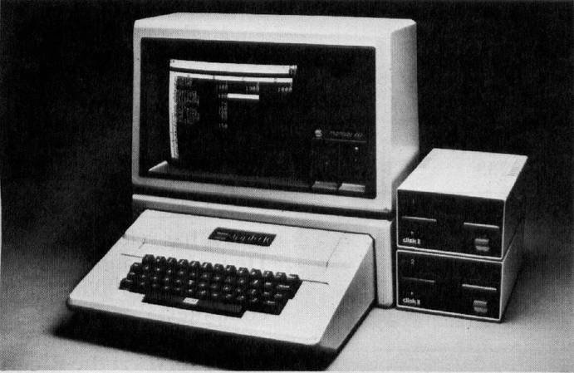  HISTORY  The follow-up to Wozniak's 1977 original. With 48 KB RAM, full keyboard and built-in colour graphics, the II+ became the best-selling computer in education for a decade.  SPECIFICATIONS  CPU: MOS 6502 · 1 MHz  RAM: 48 KB  Display: 40×24 · colour  OS: Apple DOS 3.3  DID YOU KNOW?  VisiCalc — the world's first spreadsheet — was written for the Apple II, turning a hobbyist machine into a serious business tool.  MacDau · No. 001 | MacDau Museum · Vintage Apple Collection  Apple IIe Canadian  1983 – 1993  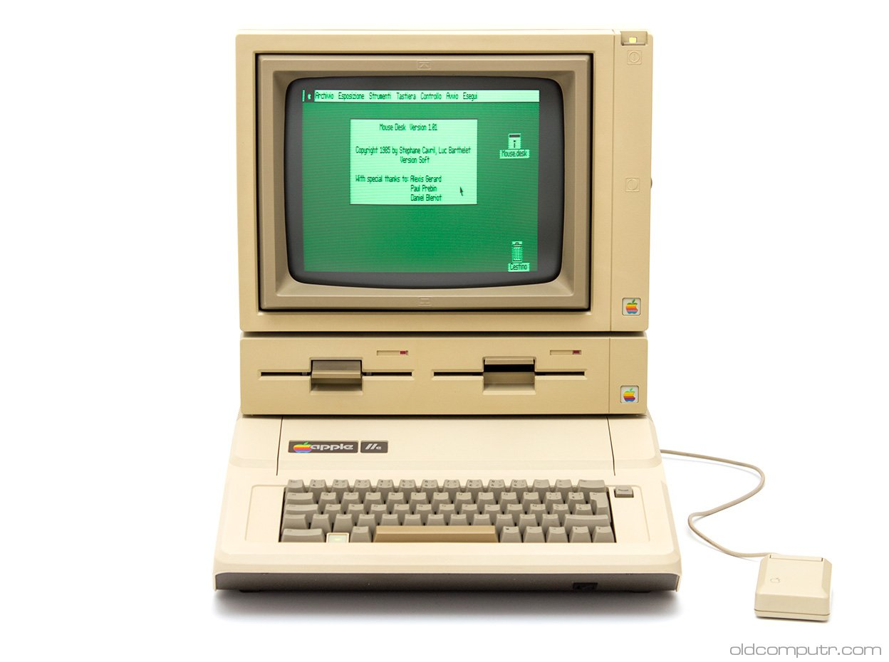  HISTORY  The most popular Apple II ever made. The Canadian variant was produced for the Canadian market, with a French-language keyboard layout and bilingual packaging.  SPECIFICATIONS  CPU: MOS 6502 · 1 MHz  RAM: 64 KB  Display: 40/80 col · colour  OS: Apple DOS 3.3  DID YOU KNOW?  The IIe stayed in production for over a decade — one of the longest-lived computer models in history.  MacDau · No. 002
MacDau Museum · Vintage Apple Collection  Apple IIe Platinum  1987 – 1993  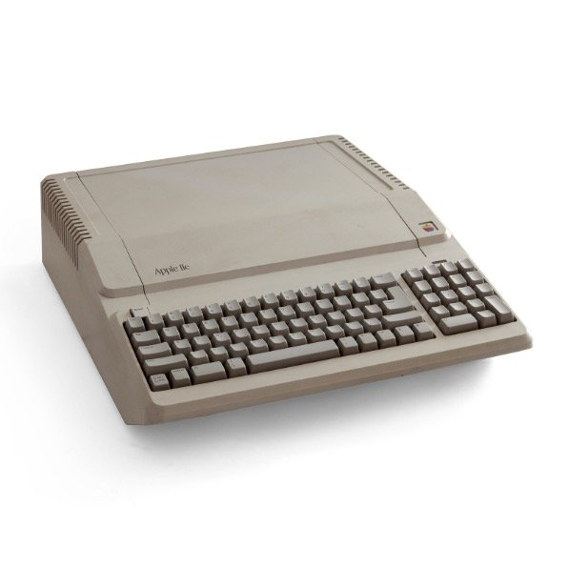  HISTORY  A refreshed IIe with a modern platinum-grey case, matching the look of the Apple IIGS. The final and most polished version of the classic IIe design.  SPECIFICATIONS  CPU: MOS 6502 · 1 MHz  RAM: 64 KB  Display: 40/80 col · colour  OS: Apple ProDOS 8  DID YOU KNOW?  The Platinum IIe was so reliable that schools kept them running well into the 1990s.  MacDau · No. 003 | MacDau Museum · Vintage Apple Collection  Apple IIc  1984 – 1990  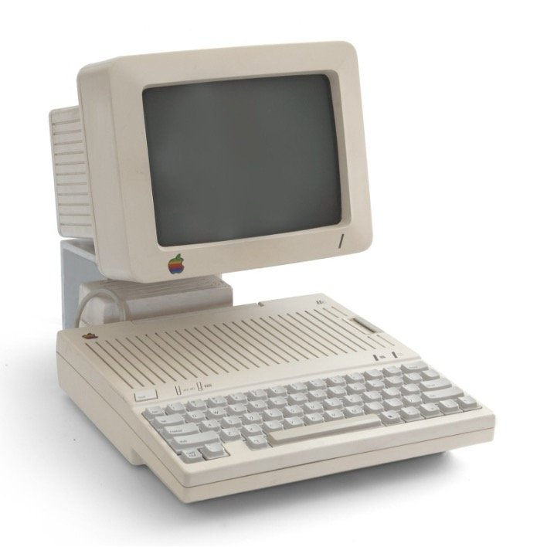  HISTORY  Apple's first truly portable computer — a compact, all-in-one II with a built-in handle. Designed to be 'the Macintosh of the Apple II line'.  SPECIFICATIONS  CPU: MOS 65C02 · 1 MHz  RAM: 128 KB  Display: 80 col · colour  Storage: 5.25″ drive  DID YOU KNOW?  The IIc was so compact that Apple marketed it with the slogan 'The most personal computer ever'.  MacDau · No. 004

MacDau Museum · Vintage Apple Collection  Apple IIc Plus  1988 – 1990  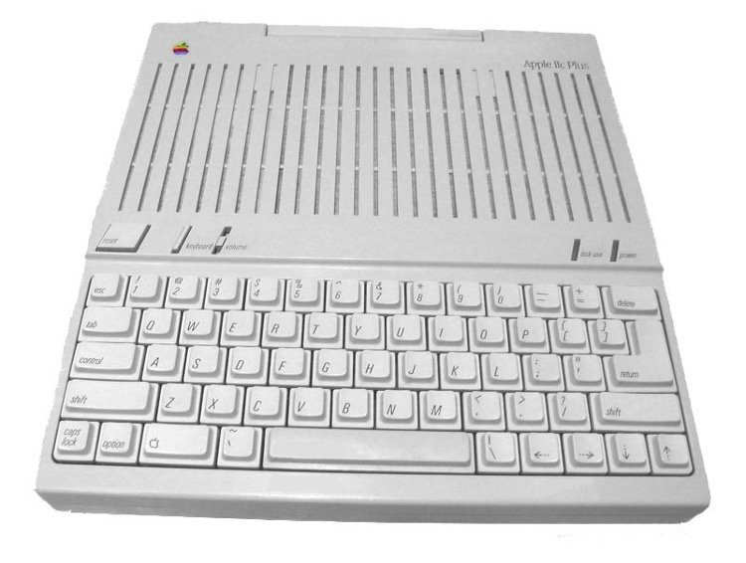  HISTORY  The fastest and final Apple II — a IIc with a 4 MHz processor and a built-in 3.5″ drive. The swan song of the Apple II family.  SPECIFICATIONS  CPU: 65C02 · 4 MHz  RAM: 128 KB  Display: 80 col · colour  Storage: 3.5″ drive  DID YOU KNOW?  The IIc+ ran software up to four times faster than the original Apple II.  MacDau · No. 005 | MacDau Museum · Vintage Apple Collection  Apple IIGS Woz edition  1986 – 1992  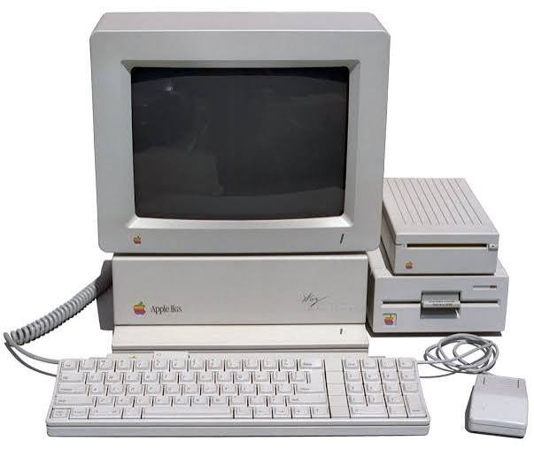  HISTORY  The most advanced Apple II, with 16-bit sound and graphics far beyond its ancestors. This Woz edition is signed by Steve Wozniak.  SPECIFICATIONS  CPU: 65C816 · 2.8 MHz  RAM: 256 KB  Display: 640×200 · 4096 colours  OS: GS/OS  DID YOU KNOW?  The IIGS could display 4096 colours and its Ensoniq sound chip made it a music powerhouse.  MacDau · No. 006
MacDau Museum · Vintage Apple Collection  Apple IIGS ROM 1  1987 – 1989  HISTORY  The second revision of the IIGS, released in 1987 to fix a notorious boot bug in the original ROM 0 — early units would hang on startup unless a disk was already in the drive.  SPECIFICATIONS  CPU: 65C816 · 2.8 MHz  RAM: 256 KB  Display: 640×200 · 4096 colours  OS: GS/OS  DID YOU KNOW?  The original ROM 0 IIGS had a boot bug that froze the machine at startup without a floppy inserted — Apple fixed it in ROM 1 and offered free upgrades to early buyers.  MacDau · No. 007 | MacDau Museum · Vintage Apple Collection  Apple IIGS ROM 3  1989 – 1992  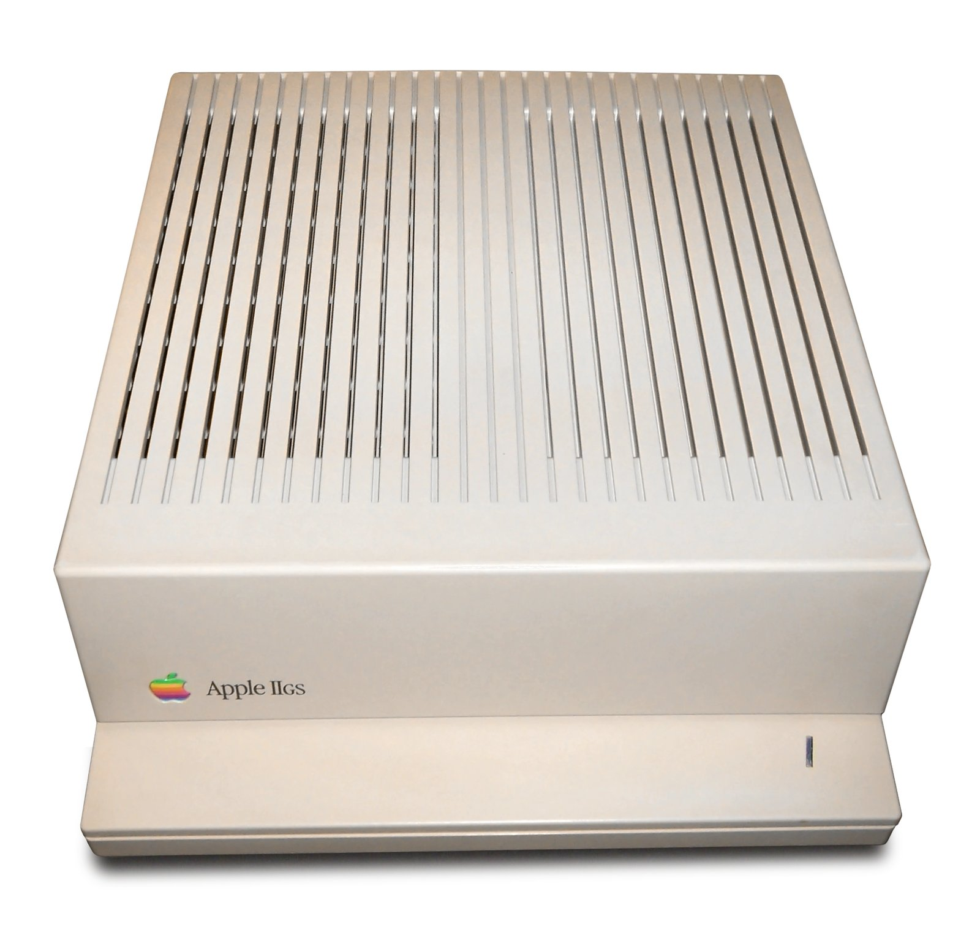  HISTORY  The final revision of the IIGS with a rewritten ROM, faster boot time and better system software support. The last major Apple II release.  SPECIFICATIONS  CPU: 65C816 · 2.8 MHz  RAM: 1.125 MB  Display: 640×200 · 4096 colours  OS: GS/OS 5  DID YOU KNOW?  ROM 3 machines booted significantly faster than earlier IIGS models.  MacDau · No. 008

MacDau Museum · Vintage Apple Collection  Macintosh 128K  1984 – 1985  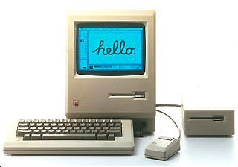  HISTORY  Announced 24 January 1984 with Ridley Scott's legendary “1984” Super Bowl ad. The first mass-market personal computer with a graphical user interface and mouse.  SPECIFICATIONS  CPU: 68000 · 7.8 MHz  RAM: 128 KB  Display: 9″ · 512×342  OS: System 1.0  DID YOU KNOW?  With only 128 KB of RAM, you had to quit MacWrite before opening MacPaint — the two could never run at the same time.  MacDau · No. 009 | MacDau Museum · Vintage Apple Collection  Macintosh Plus  1986 – 1990  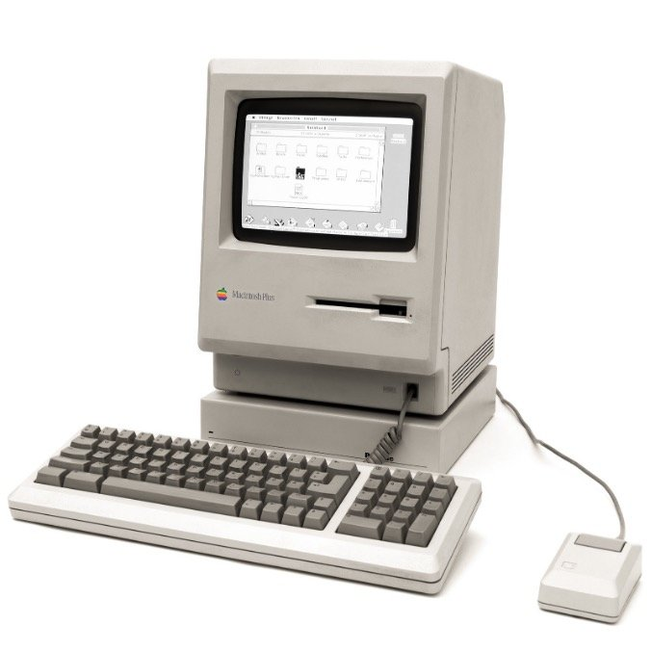  HISTORY  The Mac that matured the platform: 1 MB of RAM, SCSI port and the new 800 KB floppy drive. The best-selling Mac of its era.  SPECIFICATIONS  CPU: 68000 · 8 MHz  RAM: 1 MB  Display: 9″ · 512×342  OS: System 3.0  DID YOU KNOW?  The Plus was sold for five years — one of the longest-lived Macs ever.  MacDau · No. 010
MacDau Museum · Vintage Apple Collection  Macintosh SE FDHD  1989 – 1990  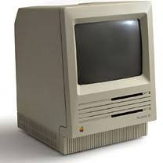  HISTORY  The SE brought an internal hard drive slot and a cleaner, more professional design. FDHD refers to the high-density 1.44 MB SuperDrive.  SPECIFICATIONS  CPU: 68000 · 8 MHz  RAM: 1 MB  Display: 9″ · 512×342  Storage: 1.44 MB SuperDrive  DID YOU KNOW?  The SE was the first Mac with an internal expansion slot — and the first to have a fan.  MacDau · No. 011 | MacDau Museum · Vintage Apple Collection  Macintosh SE/30  1989 – 1991  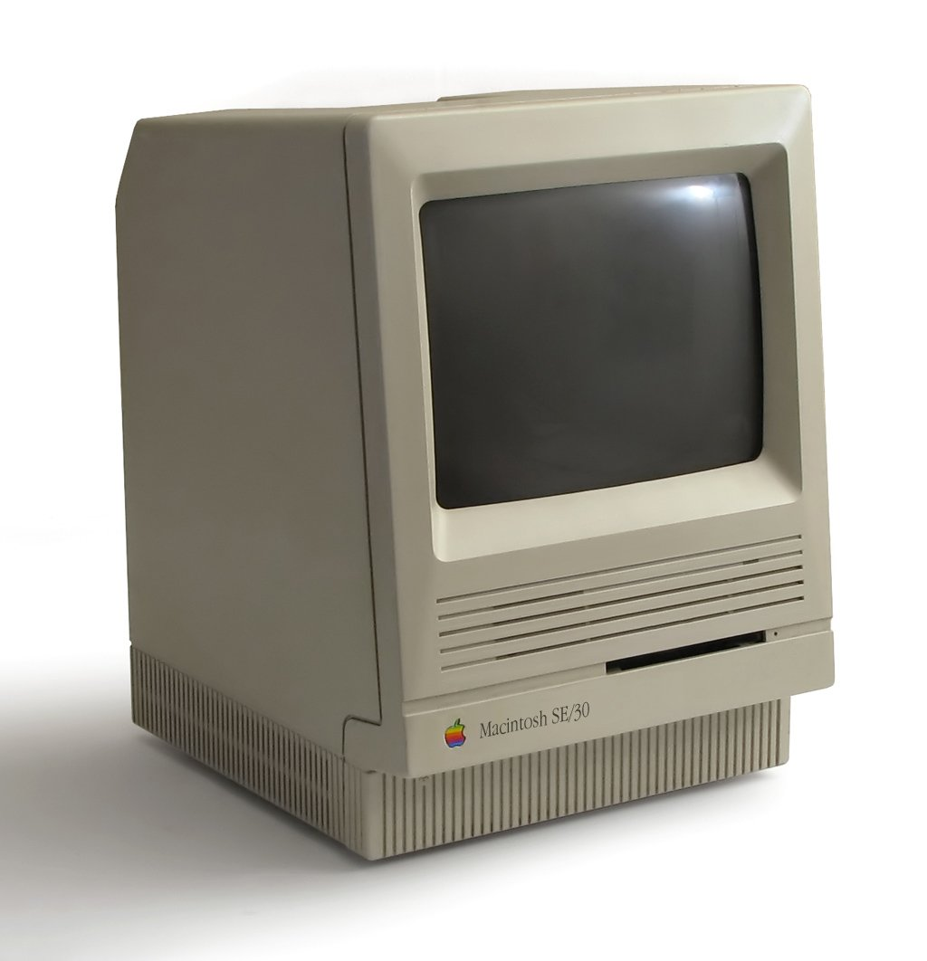  HISTORY  The ultimate compact Mac — a 16 MHz 68030 with colour-capable expansion. Still beloved by collectors as the fastest 9″ Mac ever made.  SPECIFICATIONS  CPU: 68030 · 16 MHz  RAM: 1 MB (up to 128)  Display: 9″ · 512×342  OS: System 6.0.3  DID YOU KNOW?  The SE/30 is so sought after that working units still sell for hundreds of dollars today.  MacDau · No. 012

MacDau Museum · Vintage Apple Collection  Macintosh II  1987 – 1990  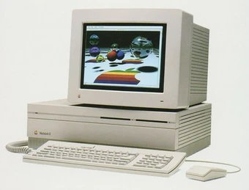  HISTORY  The first expandable, colour-capable Mac — six NuBus slots, a colour display and the famous 'frying pan' logic board. A giant leap from the 9″ classics.  SPECIFICATIONS  CPU: 68020 · 16 MHz  RAM: 1 MB  Display: colour (optional)  OS: System 4.1  DID YOU KNOW?  The Mac II's startup chime was composed by Jim Reekes on a Korg synthesizer — in his living room.  MacDau · No. 013 | MacDau Museum · Vintage Apple Collection  Macintosh IIx  1988 – 1990  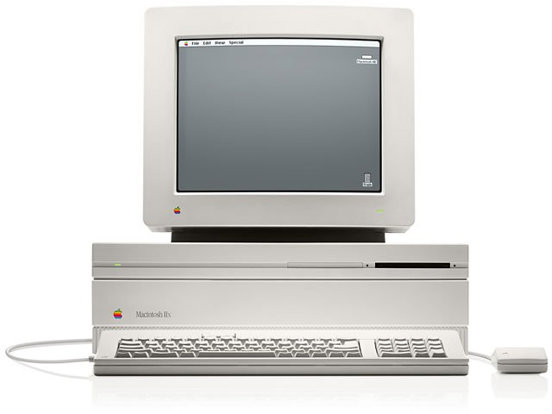  HISTORY  A faster Mac II with the 68030 CPU and 1.44 MB SuperDrive. Colour graphics still needed a NuBus video card — onboard video only arrived with the IIci.  SPECIFICATIONS  CPU: 68030 · 16 MHz  RAM: 1 MB  Display: colour (NuBus card)  OS: System 6.0  DID YOU KNOW?  The IIx was Apple's first Macintosh to ship with the 1.44 MB SuperDrive as standard.  MacDau · No. 014
MacDau Museum · Vintage Apple Collection  Macintosh IIfx  1990 – 1992  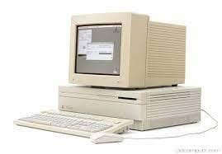  HISTORY  The fastest Mac of its day — a 40 MHz 68030 with dedicated I/O processors. Nicknamed 'Wicked Fast' inside Apple.  SPECIFICATIONS  CPU: 68030 · 40 MHz  RAM: 4 MB  Display: colour (built-in)  OS: System 6.0.5  DID YOU KNOW?  The IIfx cost over US$9,000 when new — a workstation-class price tag.  MacDau · No. 015 | MacDau Museum · Vintage Apple Collection  Macintosh Quadra 700  1991 – 1993  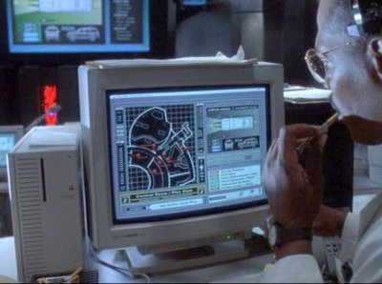  HISTORY  The 'Jurassic Macintosh' — the machine that runs the park's control system in Jurassic Park (1993). One of the first 68040 Macs, and the first tower-style Mac.  SPECIFICATIONS  CPU: 68040 · 25 MHz  RAM: 4 MB  Display: colour · 24-bit  OS: System 7.0.1  DID YOU KNOW?  In the film, the park's 3D 'system control' graphics were actually rendered live on the Quadra 700.  MacDau · No. 016

MacDau Museum · Vintage Apple Collection  Macintosh Color Classic  1993 – 1994  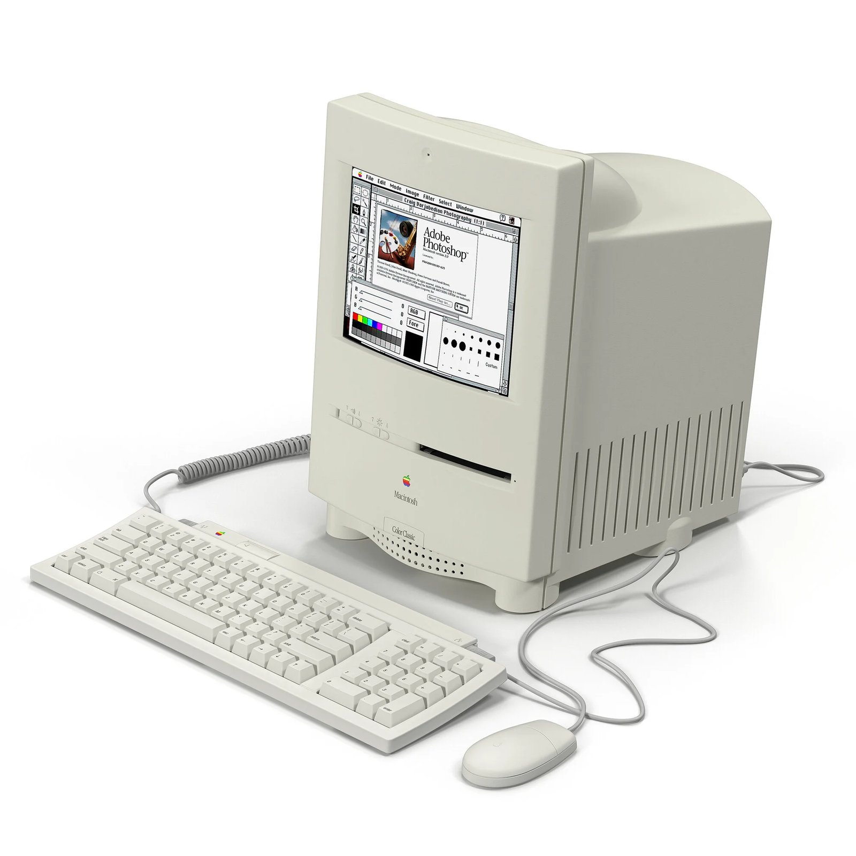  HISTORY  The classic 9″ Mac design, finally in colour. A compact all-in-one that charmed the education market — and collectors today.  SPECIFICATIONS  CPU: 68030 · 16 MHz  RAM: 4 MB  Display: 10″ colour  OS: System 7.1  DID YOU KNOW?  The Color Classic is the only compact Mac with a colour screen — the last of the 9″-style all-in-ones.  MacDau · No. 017 | MacDau Museum · Vintage Apple Collection  Macintosh Color Classic Mystic  1993 – 1994  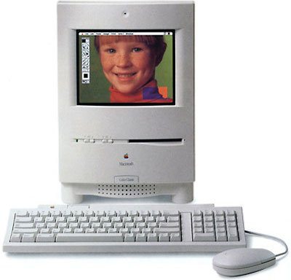  HISTORY  The 'Mystic' is a legendary upgrade: an LC 575 logic board inside the Color Classic case, tripling the CPU speed. A favourite mod among retro enthusiasts.  SPECIFICATIONS  CPU: 68LC040 · 33 MHz  RAM: 36 MB  Display: 10″ colour  OS: System 7.1.2  DID YOU KNOW?  The Mystic mod is named after the Apple band 'Mystic' — and makes the little Color Classic scream.  MacDau · No. 018
MacDau Museum · Vintage Apple Collection  Macintosh LC III  1993 – 1994  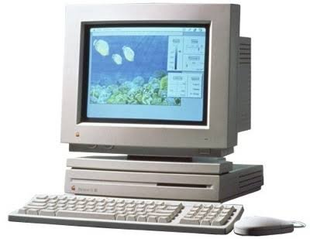  HISTORY  The third-generation LC — a compact, affordable colour Mac for home and school. A 68030 upgrade made it a big step up from the LC II.  SPECIFICATIONS  CPU: 68030 · 25 MHz  RAM: 4 MB  Display: colour (12-bit)  OS: System 7.1  DID YOU KNOW?  The LC series name stood for 'Low Cost Colour' — Apple's push into affordable colour computing.  MacDau · No. 019 | MacDau Museum · Vintage Apple Collection  Macintosh LC 475  1993 – 1995  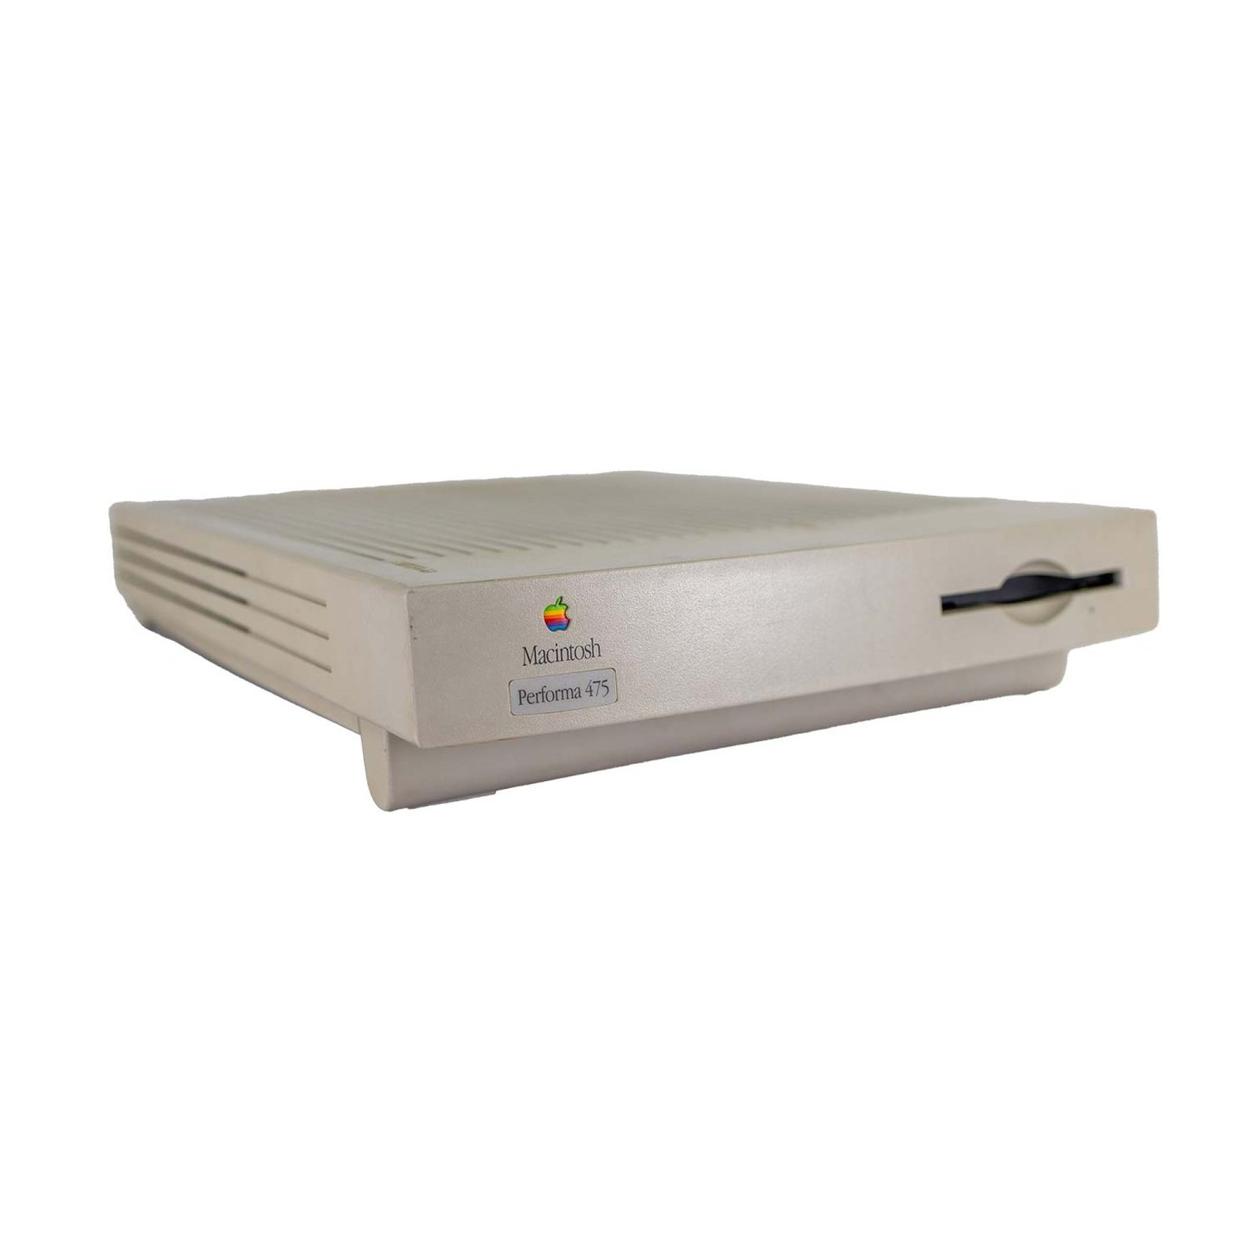  HISTORY  A compact Mac with a 68040-class CPU at a budget price. Often sold under several names: LC 475, Performa 475 and Quadra 605.  SPECIFICATIONS  CPU: 68LC040 · 25 MHz  RAM: 4 MB  Display: colour (built-in)  OS: System 7.1  DID YOU KNOW?  The same machine was sold as the Quadra 605 — the cheapest Quadra ever made.  MacDau · No. 020

MacDau Museum · Vintage Apple Collection  Macintosh Quadra 605  1993 – 1994  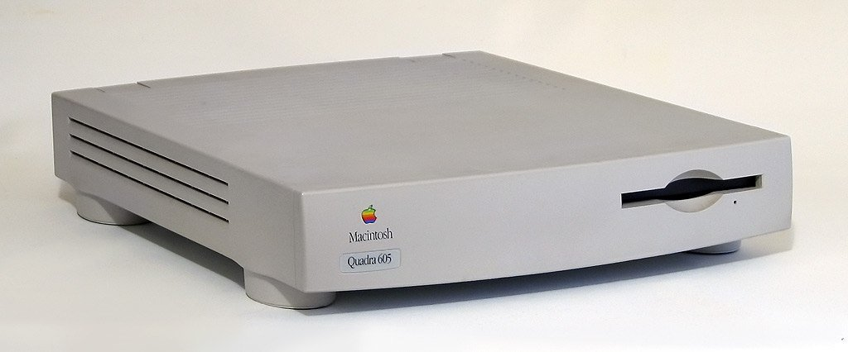  HISTORY  The cheapest Quadra ever — Apple's least expensive Mac at launch in October 1993. A 25 MHz 68LC040 in the slim LC III-style case, sold under three names: Quadra for business, LC 475 for education, Performa 475 for home.  SPECIFICATIONS  CPU: 68LC040 · 25 MHz  RAM: 4 MB  Display: colour (built-in)  OS: System 7.1  DID YOU KNOW?  The LC 475 beside it (No. 020) is the same machine — Apple sold one logic board under three names for three markets: Quadra, LC and Performa.  MacDau · No. 021 | MacDau Museum · Vintage Apple Collection  Macintosh LC 575  1994 – 1995  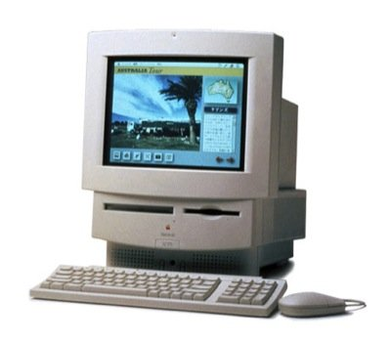  HISTORY  A 68LC040-powered all-in-one with a 14″ colour display — the heart of many 1990s classrooms. Its logic board later powered the legendary Color Classic 'Mystic' mod.  SPECIFICATIONS  CPU: 68LC040 · 33 MHz  RAM: 8 MB  Display: 14″ colour  OS: System 7.1.2  DID YOU KNOW?  The LC 575's 33 MHz board became the most famous donor for Color Classic upgrades.  MacDau · No. 022
MacDau Museum · Vintage Apple Collection  Power Macintosh 5400/180  1996 – 1997  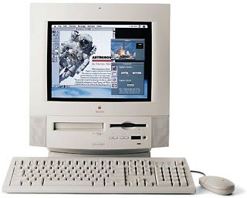  HISTORY  A PowerPC all-in-one with a sleek curved design, built for education. The 180 MHz 603e made it a capable multimedia machine.  SPECIFICATIONS  CPU: PPC 603e · 180 MHz  RAM: 16 MB  Display: 15″ colour  OS: System 7.5.3  DID YOU KNOW?  The 5400's tower sibling was the Power Macintosh 5400/200 — one of the first machines to ship with an internal Zip drive option.  MacDau · No. 023 | MacDau Museum · Vintage Apple Collection  Power Macintosh 6100/66 DOS Compatible  1995 – 1995  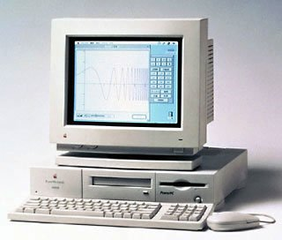  HISTORY  A Power Mac with a built-in 486 DX2/66 PC card — one machine, two computers. Apple's answer to 'why can't I run Windows?'.  SPECIFICATIONS  CPU: PPC 601 · 66 MHz  RAM: 8 MB  Display: colour  OS: System 7.5  DID YOU KNOW?  The DOS Compatibility Card included a full 486 processor — you could run Windows 3.1 in a window.  MacDau · No. 024

MacDau Museum · Vintage Apple Collection  Power Macintosh G3 Beige Desktop  1997 – 1999  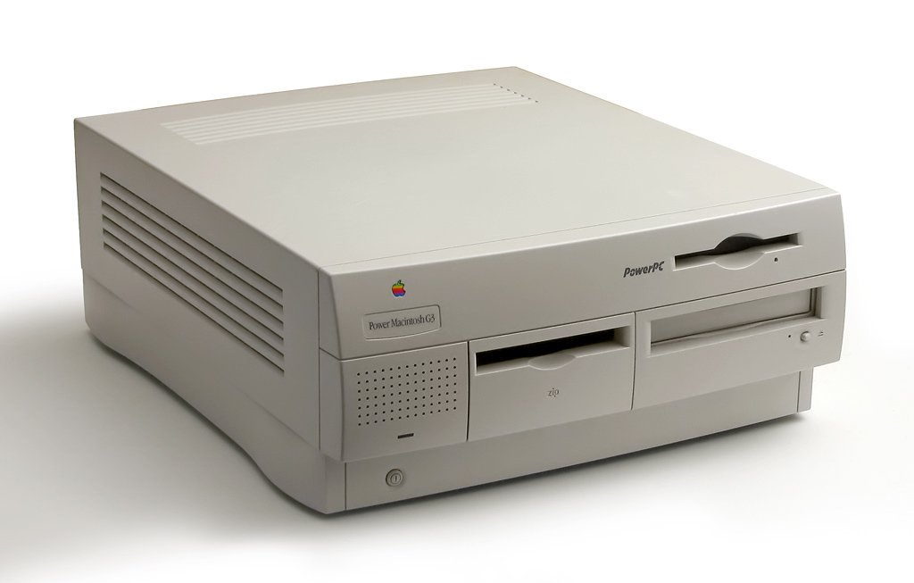  HISTORY  The G3 desktop delivered a massive speed jump over the Power Mac 9500 — at half the price. The machine that helped save Apple.  SPECIFICATIONS  CPU: PPC 750 G3 · 233 MHz  RAM: 32 MB  Display: colour  OS: Mac OS 8.0  DID YOU KNOW?  Steve Jobs announced the G3's speed claim with a dramatic on-stage benchmark against a Pentium II.  MacDau · No. 025 | MacDau Museum · Vintage Apple Collection  iMac G4 Cube  2000 – 2001  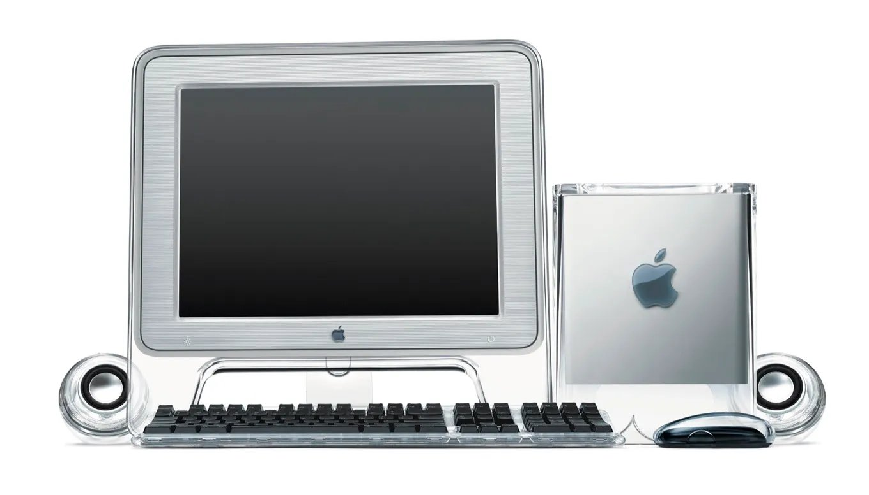  HISTORY  A stunning 8-inch cube of clear polycarbonate with a G4 inside — no fan, just silence. Steve Jobs called it 'the most beautiful computer we've ever made'.  SPECIFICATIONS  CPU: PPC 7400 G4 · 450 MHz  RAM: 64 MB  Display: external  OS: Mac OS 9  DID YOU KNOW?  The Cube could hold an optional 4-port Gigabit Ethernet card — rare for its time.  MacDau · No. 026
MacDau Museum · Vintage Apple Collection  Power Mac G5 Dual Processors  2003 – 2006  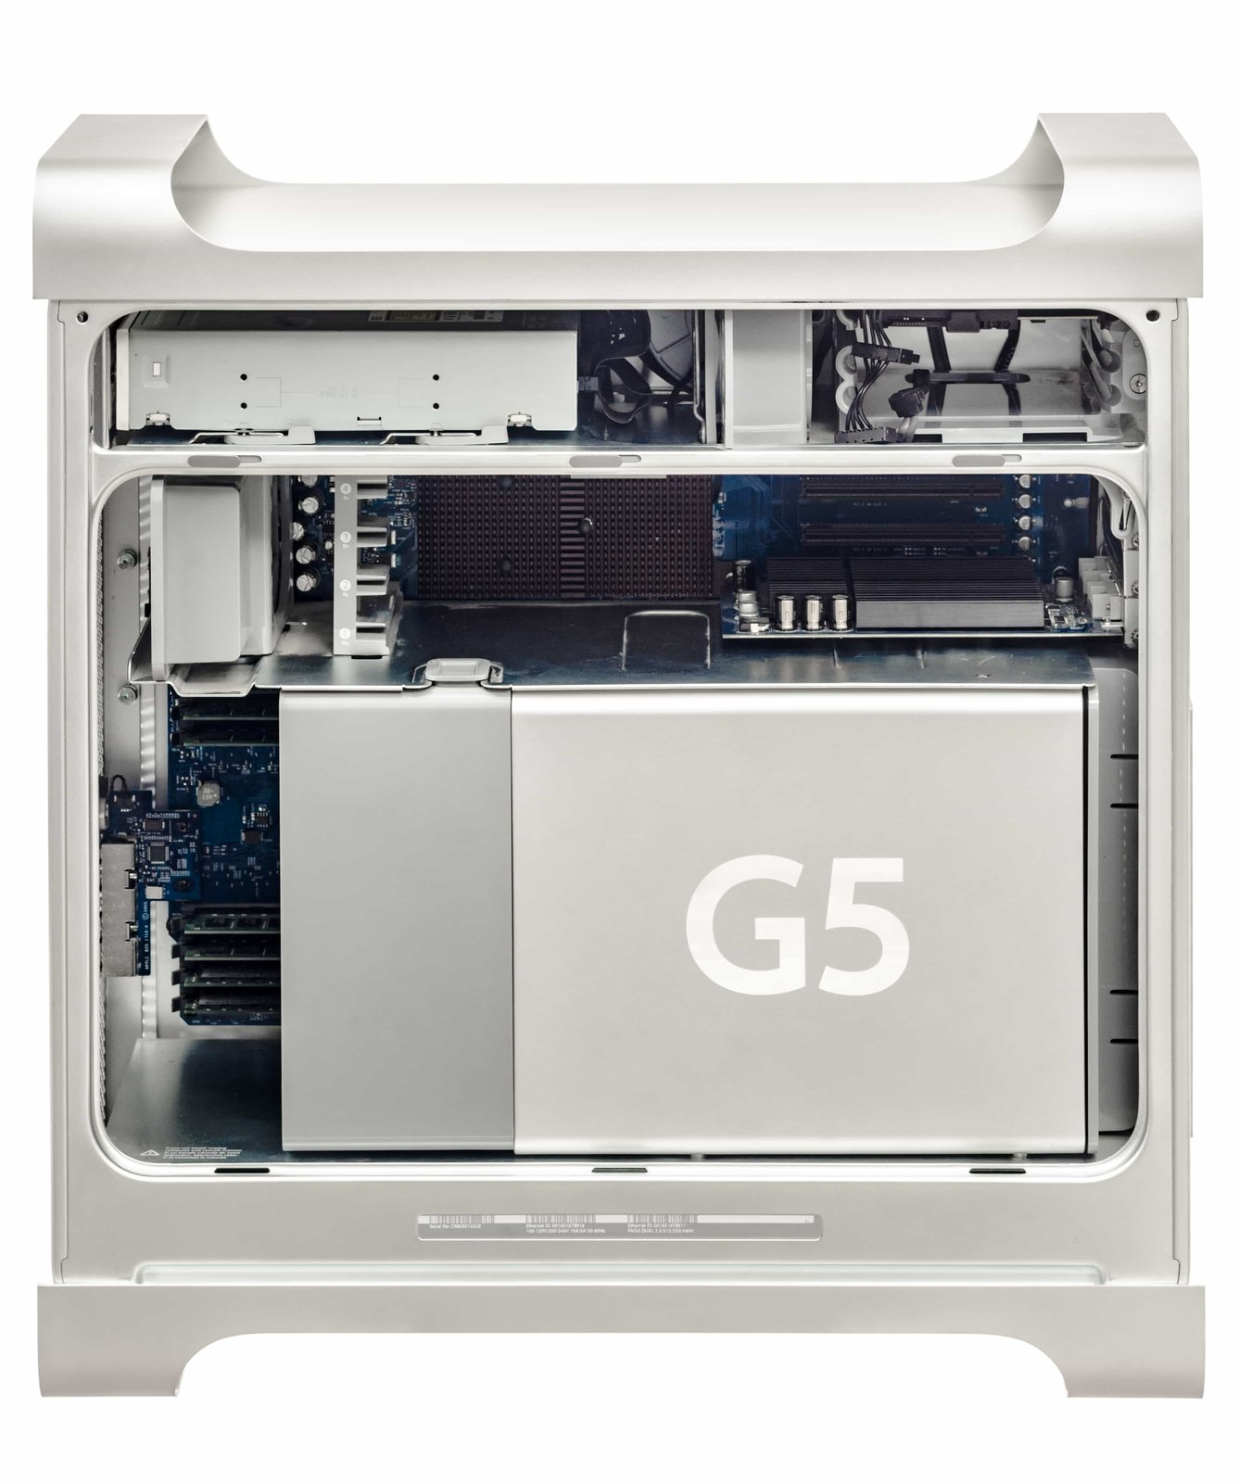  HISTORY  The first 64-bit Mac — a liquid-cooled aluminium tower with dual PowerPC G5 processors. Built by IBM, it was Apple's fastest machine ever at launch.  SPECIFICATIONS  CPU: 2× PPC 970 · 2.0 GHz  RAM: 512 MB  Display: external  OS: Mac OS X 10.3  DID YOU KNOW?  The G5's enclosure was so large that it held nine fans — and was the basis for the Mac Pro design that followed.  MacDau · No. 027 | MacDau Museum · Vintage Apple Collection  Mac Pro (Early 2009)  2009 – 2010  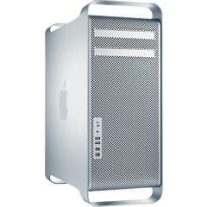  HISTORY  The Mac Pro (Early 2009) was the first "Nehalem" Mac Pro — Intel's new Xeon 5500 architecture with an integrated memory controller and DDR3 RAM. A major internal redesign inside the familiar aluminium cheese-grater tower.  SPECIFICATIONS  CPU: Xeon W3520 · 2.66 GHz (4-core)  RAM: 6 GB DDR3 (up to 16)  Display: external  OS: Mac OS X 10.5.7  DID YOU KNOW?  The Early 2009 was the first Mac Pro with DDR3 memory — and its Nehalem Xeon had the memory controller built into the CPU die, slashing memory latency.  MacDau · No. 028

MacDau Museum · Vintage Apple Collection  Mac Pro (Mid 2012)  2012 – 2013  HISTORY  The last of the classic cheese-grater towers: dual 6-core Xeon processors, 12 cores, up to 64 GB RAM. A workstation legend that outlived its successors.  SPECIFICATIONS  CPU: 2× Xeon X5690 · 3.46 GHz  RAM: 6 GB (up to 64)  Display: external  OS: OS X 10.7 Lion  DID YOU KNOW?  This 2012 model is the most powerful 'cheese grater' Mac Pro — and the last Mac with FireWire 800.  MacDau · No. 029 | MacDau Museum · Vintage Apple Collection  Twentieth Anniversary Macintosh  1997 – 1998  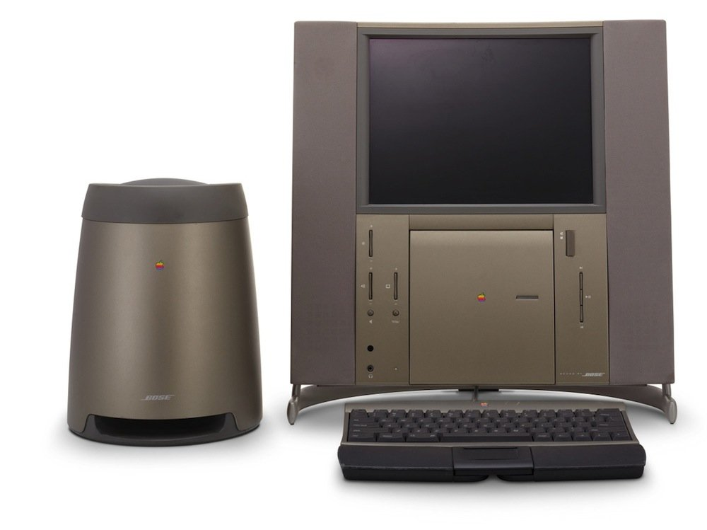  HISTORY  A luxury Macintosh celebrating Apple's 20 years: 12.1″ LCD, Bose sound system and TV tuner — at US$7,499. Only around 12,000 units were produced.  SPECIFICATIONS  CPU: PPC 603e · 250 MHz  RAM: 32 MB  Display: 12.1″ LCD  OS: Mac OS 7.6.1  DID YOU KNOW?  Buyers received white-glove home delivery — Apple technicians personally arrived to set the machine up in your living room.  MacDau · No. 030
MacDau Museum · Vintage Apple Collection  Power Macintosh 7100/66  1994 – 1996  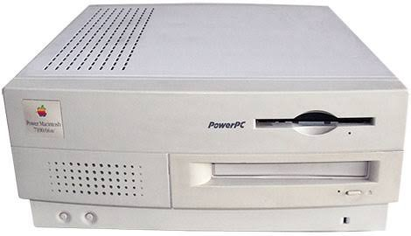  HISTORY  A mid-range Power Mac based on the 6100 architecture, offering fast PowerPC performance in a friendly pizza-box case.  SPECIFICATIONS  CPU: PPC 601 · 66 MHz  RAM: 8 MB  Display: colour  OS: System 7.1.2  DID YOU KNOW?  In 1994 a 7100 was famously 'upgraded' with a 68040 card to run both Mac OS and A/UX.  MacDau · No. 031 | MacDau Museum · Vintage Apple Collection  Macintosh Classic  1990 – 1992  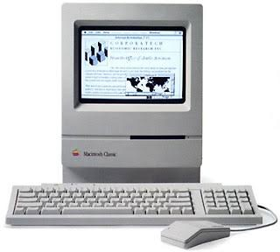  HISTORY  The affordable Mac that sold over a million units — a compact 9″ machine at under US$1,000. The Mac for the masses.  SPECIFICATIONS  CPU: 68000 · 8 MHz  RAM: 1 MB  Display: 9″ · 512×342  OS: System 6.0.7  DID YOU KNOW?  The Classic was the cheapest Mac ever sold until the Mac mini arrived 15 years later.  MacDau · No. 032

MacDau Museum · Vintage Apple Collection  NeXTstation  1990 – 1993  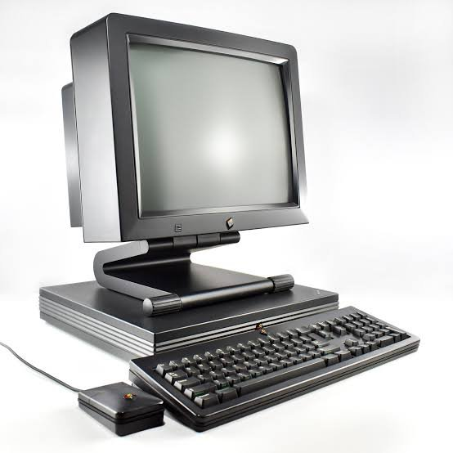  HISTORY  Steve Jobs' NeXT workstation — a sleek 'pizza box' running UNIX with a graphical interface. Tim Berners-Lee used one to invent the World Wide Web.  SPECIFICATIONS  CPU: 68040 · 25 MHz  RAM: 8 MB  Display: 17″ mono/colour  OS: NeXTSTEP 2.1  DID YOU KNOW?  The very first web server, info.cern.ch, ran on a NeXT computer — the web was born on this platform.  MacDau · No. 033 | MacDau Museum · Vintage Apple Collection  JLPGA PowerBook 170  1991 – 1992  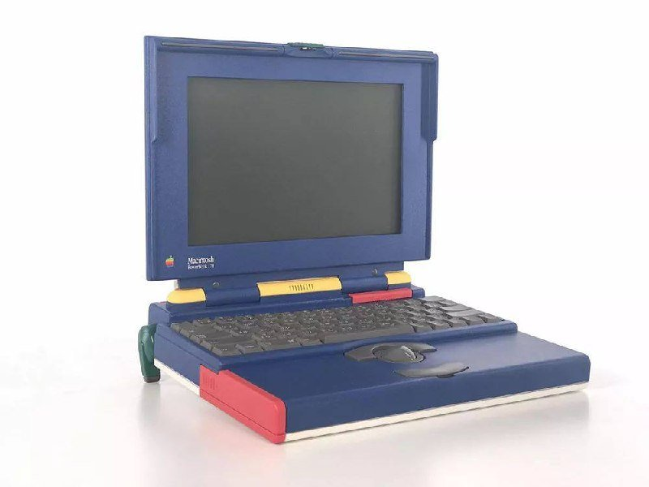  HISTORY  The PowerBook 170 was Apple's first active-matrix laptop. This JLPGA edition is a rare Japanese-market special in United Colors of Benetton styling, made for the Japan Ladies Professional Golf Association.  SPECIFICATIONS  CPU: 68030 · 25 MHz  RAM: 4 MB  Display: 10″ active-matrix · greyscale  OS: System 7.0.1  DID YOU KNOW?  Only about 500 were made — collectors call it the 'Benetton Mac' for its United Colors of Benetton colors.  MacDau · No. 034
MacDau Museum · Vintage Apple Collection  eMate 300  1997 – 1998  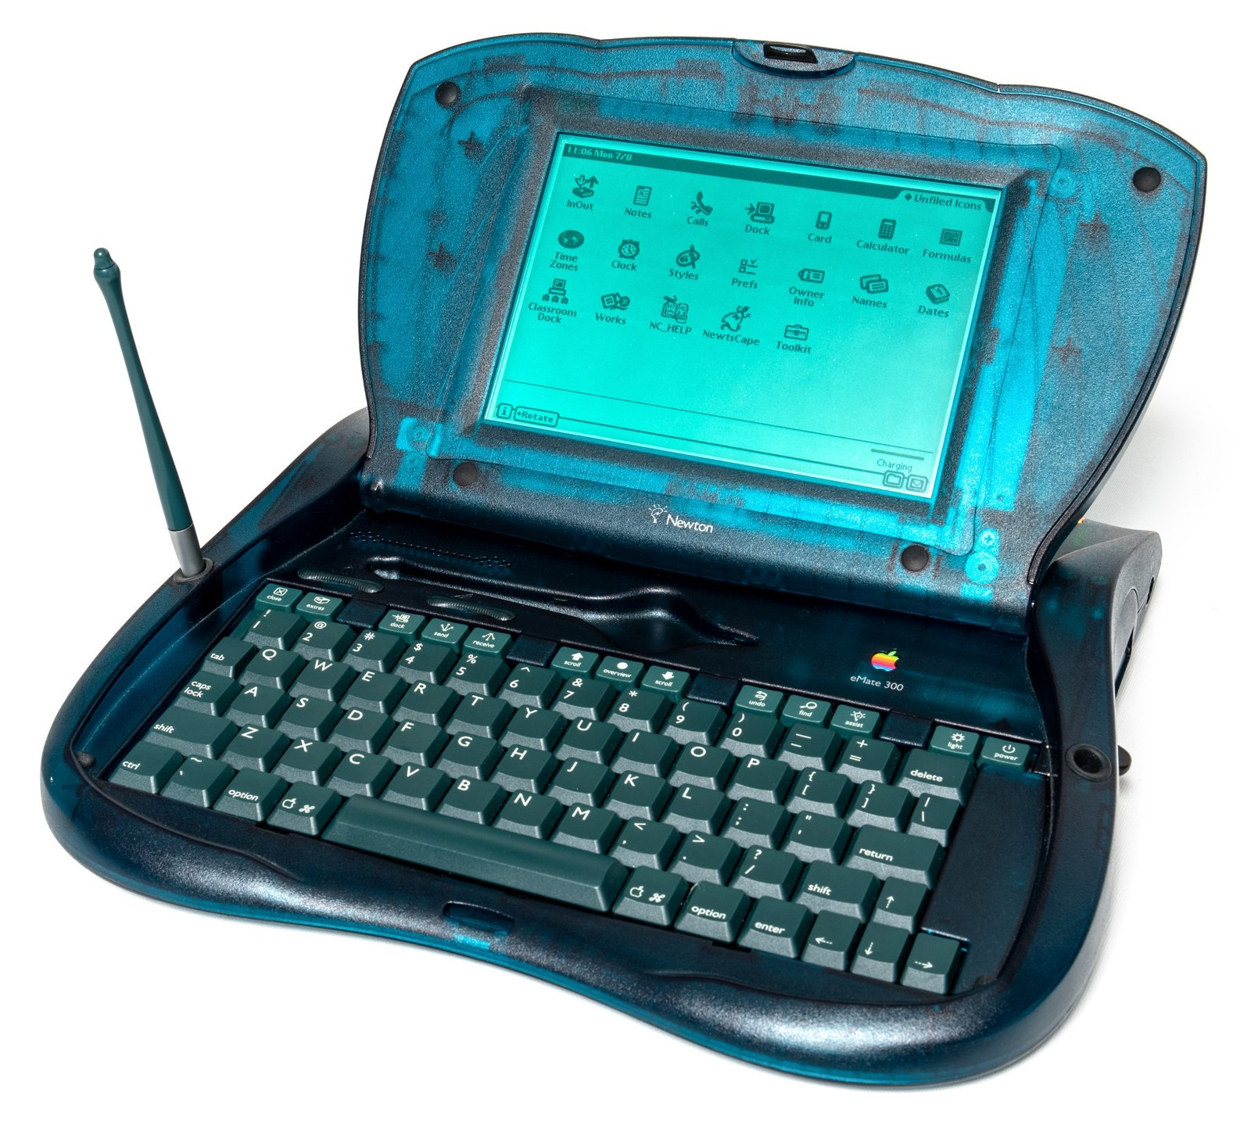  HISTORY  The eMate 300 was Apple's affordable Newton for the classroom — a rugged green clamshell with a full keyboard, powered by a rechargeable battery pack that lasted up to 28 hours.  SPECIFICATIONS  CPU: ARM 710a · 25 MHz  RAM: 3 MB  Display: 480×320 · greyscale  OS: Newton OS 2.2  DID YOU KNOW?  The eMate's translucent green case beat the iMac to the 'fun, coloured plastic' look by a full year.  MacDau · No. 035 | MacDau Museum · Vintage Apple Collection  MessagePad 2000  1997 – 1998  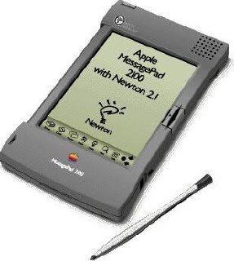  HISTORY  The fastest Newton ever made — a 162 MHz StrongARM processor with handwriting recognition that finally worked well. The apex of Apple's Newton platform.  SPECIFICATIONS  CPU: StrongARM SA-110 · 162 MHz  RAM: 5 MB (8 MB ROM)  Display: 480×320 · greyscale  OS: Newton OS 2.1  DID YOU KNOW?  The MessagePad 2000's handwriting recognition was so good it became the benchmark — yet Apple cancelled Newton just months after this model shipped.  MacDau · No. 036

MacDau Museum · Vintage Apple Collection  iBook  1999 – 2001  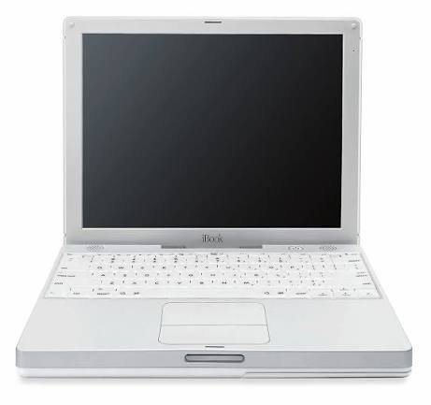  HISTORY  The original iBook — a colourful clamshell laptop with a handle, aimed at consumers. The first mainstream notebook with built-in AirPort Wi-Fi.  SPECIFICATIONS  CPU: PowerPC G3 · 300 MHz  RAM: 32 MB  Display: 12.1″ · 800×600  OS: Mac OS 8.6  DID YOU KNOW?  Steve Jobs showed off the iBook's Wi-Fi on stage by jumping through a hula hoop — the 'iBook is wireless' moment.  MacDau · No. 037 | MacDau Museum · Vintage Apple Collection  PowerBook G4 12"  2003 – 2006  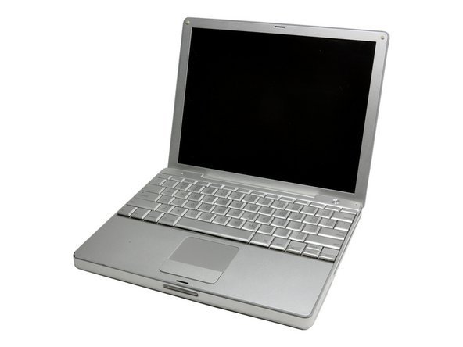  HISTORY  The first 12-inch PowerBook — an aluminium notebook that packed G4 power into the most compact body Apple had made. A design loved by travellers.  SPECIFICATIONS  CPU: PowerPC G4 · 1 GHz  RAM: 256 MB  Display: 12.1″ · 1024×768  OS: Mac OS X 10.2  DID YOU KNOW?  The 12" PowerBook G4 was the smallest PowerBook ever — and its aluminium body set the template for the MacBook Pro.  MacDau · No. 038
MacDau Museum · Vintage Apple Collection  MessagePad  1993 – 1994  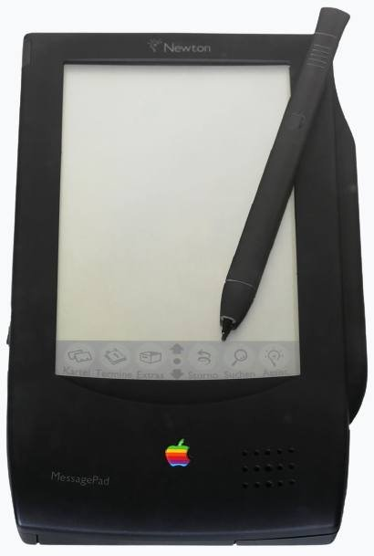  HISTORY  Apple's first Newton — the original MessagePad (H1000). Unveiled by John Sculley at Macworld 1993, it launched the personal digital assistant category with a stylus-driven touchscreen and Newton OS.  SPECIFICATIONS  CPU: ARM 610 · 20 MHz  RAM: 640 KB  Display: 336×240 · greyscale  OS: Newton OS 1.0  DID YOU KNOW?  Sculley coined the term 'personal digital assistant' for this machine — but its handwriting recognition was so erratic that Doonesbury turned it into a running joke.  MacDau · No. 039 | MacDau Museum · Vintage Apple Collection  QuickTake 200  1997 – 1997  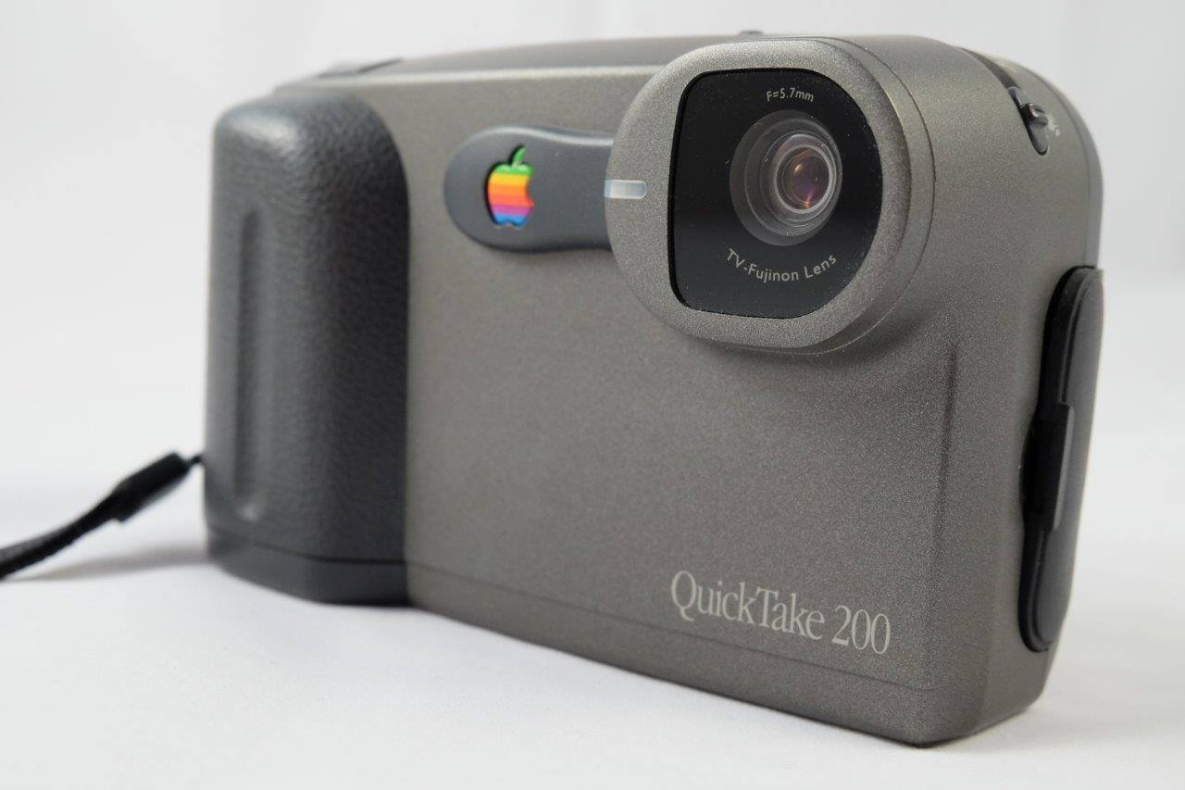  HISTORY  Apple's final QuickTake — a rebadged Fujifilm DS-7. A 0.3-megapixel compact with removable SmartMedia storage and a built-in colour LCD for reviewing shots.  SPECIFICATIONS  Sensor: 0.3 MP CCD  Resolution: 640×480 · VGA  Storage: SmartMedia card  Display: 1.8″ colour LCD  DID YOU KNOW?  Steve Jobs killed the QuickTake line within months of returning to Apple in 1997 — so the QuickTake 200 became Apple's last-ever branded camera.  MacDau · No. 040

MacDau Museum · Vintage Apple Collection  iMac G4 15″  2002 – 2004  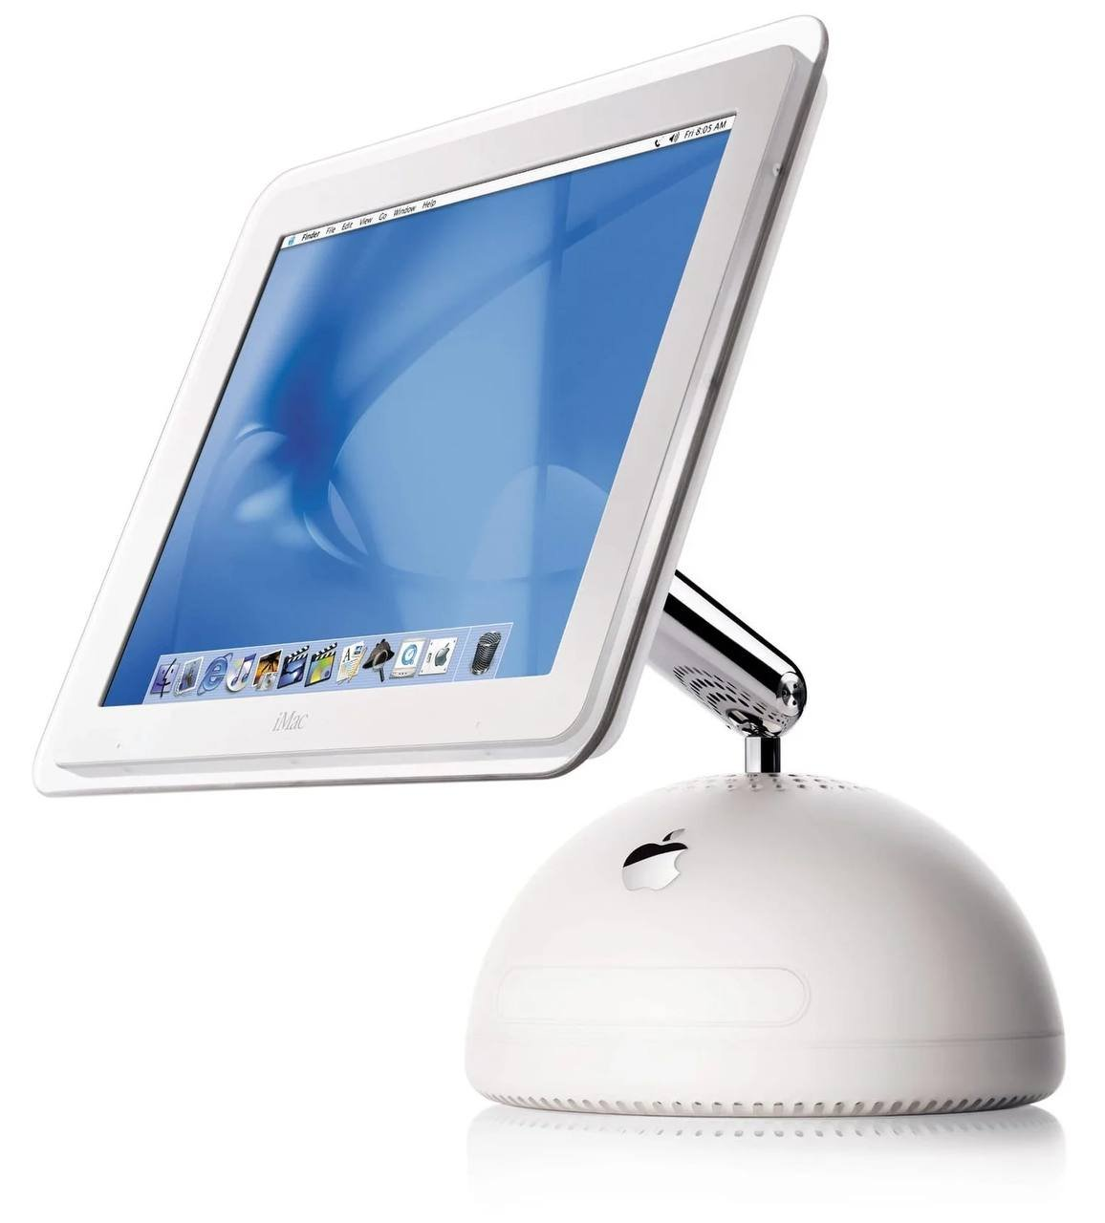  HISTORY  The 'sunflower' iMac — a flat-panel LCD floating on a swivelling chrome arm above a white dome base. Steve Jobs unveiled it at Macworld 2002, replacing the colourful iMac G3.  SPECIFICATIONS  CPU: PowerPC G4 · 700 MHz  RAM: 256 MB  Display: 15″ LCD · 1024×768  OS: Mac OS X 10.1  DID YOU KNOW?  The iMac G4's arm was balanced so precisely that you could swing the whole screen with a single finger — and it would stay exactly where you left it.  MacDau · No. 041 | MacDau Museum · Vintage Apple Collection  MacBook Pro 17"  2006 – 2008  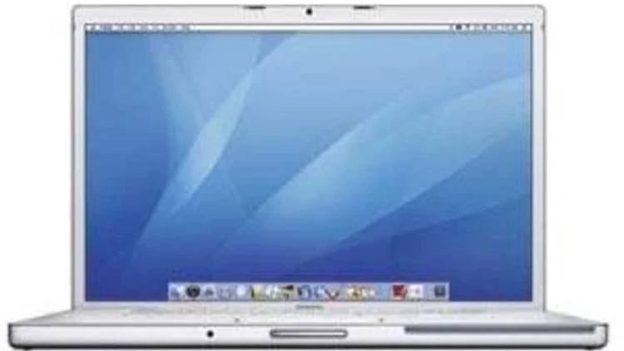  HISTORY  Apple's first Intel-powered 17-inch notebook, announced in April 2006. It kept the PowerBook G4's aluminium body but swapped in an Intel Core Duo — the first 17-inch Mac to run Intel.  SPECIFICATIONS  CPU: Intel Core Duo · 2.16 GHz  RAM: 1 GB (up to 2 GB)  Display: 17″ · 1680×1050  OS: Mac OS X 10.4 Tiger  DID YOU KNOW?  The 17-inch MacBook Pro looked almost identical to the PowerBook G4 it replaced — the giveaway was the built-in iSight camera above the screen, which the PowerBook line never had.  MacDau · No. 042
MacDau Museum · Vintage Apple Collection  Macintosh LC II  1992 – 1993  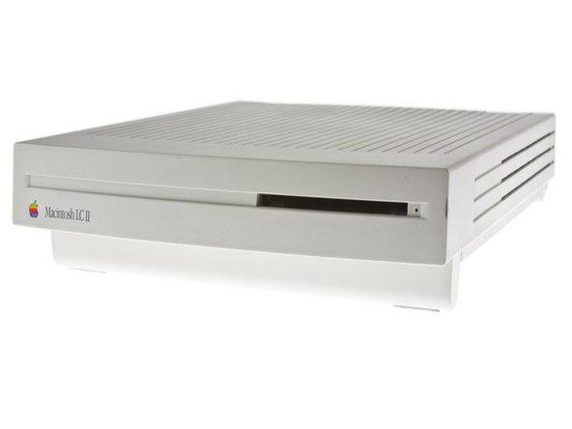  HISTORY  The Macintosh LC II, released in March 1992, refreshed Apple's budget 'pizza-box' Mac for homes and schools. It swapped the original LC's 68020 for a 68030 at 16 MHz and doubled the memory to 4 MB, priced US$800 below its predecessor.  SPECIFICATIONS  CPU: Motorola 68030 · 16 MHz  RAM: 4 MB (max 10 MB)  Display: 512×384 · 256 colours  OS: System 7.0.1  DID YOU KNOW?  Despite the 'faster' 68030 CPU, Apple kept the LC II's 16-bit data bus — so real-world speed was barely better than the original LC it replaced.  MacDau · No. 043 | MacDau Museum · Vintage Apple Collection  Apple Adjustable Keyboard  1993 – 1994  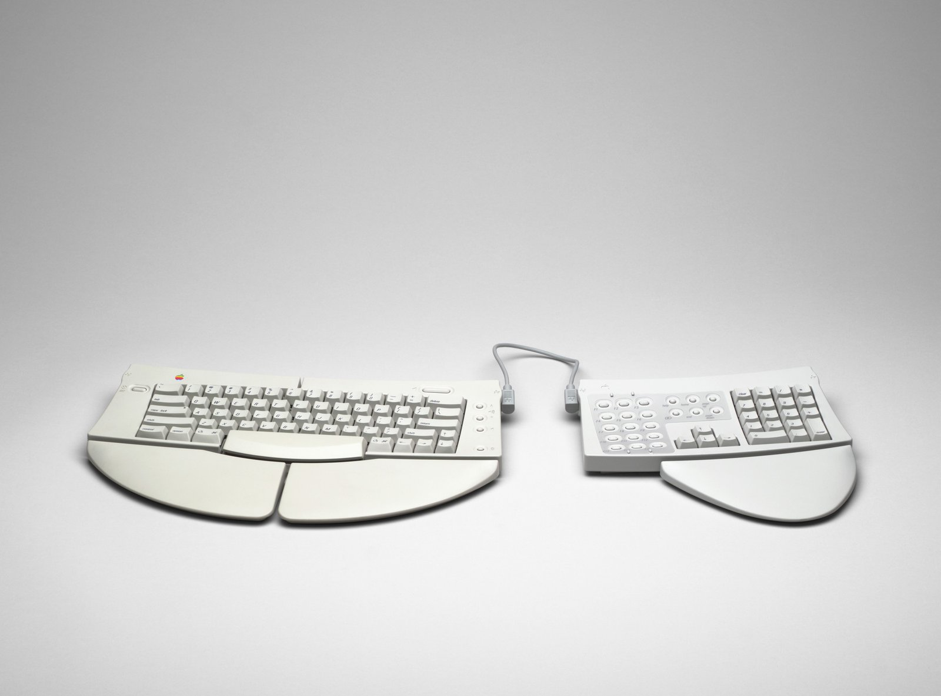  HISTORY  Apple's first and only ergonomic keyboard, introduced in 1993. Its split alphanumeric section hinges open up to 30 degrees to keep wrists in a neutral position, with detachable palm rests and a separate numeric keypad.  SPECIFICATIONS  Connection: ADB  Keys: 111 · split to 30°  Switches: Alps SKFS  OS: System 6.0.7+  DID YOU KNOW?  Despite its ergonomic ambitions, Apple discontinued it in 1994 after criticism of its build quality — its first and last adjustable keyboard.  MacDau · No. 044

MacDau Museum · Vintage Apple Collection  iPhone (1st generation)  2007 – 2008  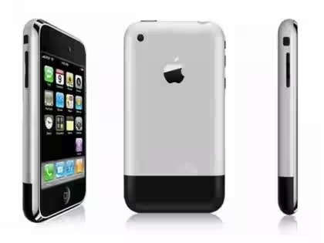  HISTORY  The device that redefined the mobile phone — a phone, iPod and internet communicator in one. Announced at Macworld 2007, it went on sale 29 June 2007 in the United States.  SPECIFICATIONS  CPU: ARM1176 · 620 MHz  RAM: 128 MB  Display: 3.5″ · 320×480  OS: iPhone OS 1.0  DID YOU KNOW?  The original iPhone had no App Store at launch — Jobs pushed web apps first, and third-party apps arrived a year later.  MacDau · No. 045 | MacDau Museum · Vintage Apple Collection  iPhone 3GS  2009 – 2012  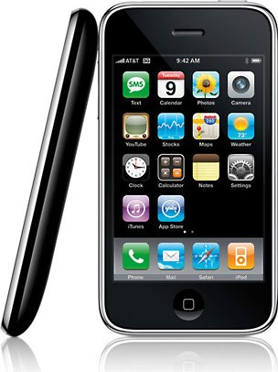  HISTORY  The 'S' stood for speed — roughly twice the performance of the 3G, with video recording and a better camera.  SPECIFICATIONS  CPU: ARM Cortex-A8 · 600 MHz  RAM: 256 MB  Display: 3.5″ · 320×480  OS: iOS 3.0  DID YOU KNOW?  The first iPhone with video recording — and the first with 32 GB of storage.  MacDau · No. 046
MacDau Museum · Vintage Apple Collection  iPhone 4S  2011 – 2014  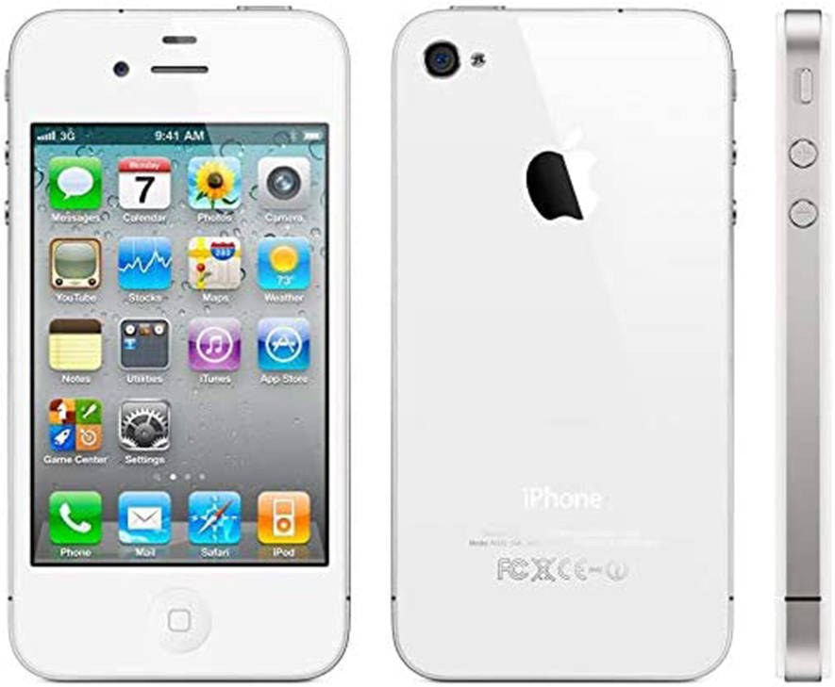  HISTORY  Announced on 4 October 2011 — the day before Steve Jobs died. It brought Siri, the dual-core A5 chip and an 8-megapixel camera.  SPECIFICATIONS  CPU: Apple A5 · dual-core  RAM: 512 MB  Display: 3.5″ Retina · 960×640  OS: iOS 5  DID YOU KNOW?  Siri made its debut on the 4S — Apple's voice assistant caught the world by surprise.  MacDau · No. 047 | MacDau Museum · Vintage Apple Collection  iPhone 5S  2013 – 2016  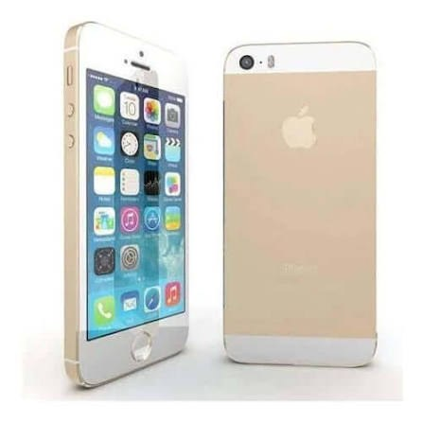  HISTORY  The first 64-bit smartphone — the A7 chip and the Touch ID fingerprint sensor defined the 5S.  SPECIFICATIONS  CPU: Apple A7 · 64-bit  RAM: 1 GB  Display: 4″ Retina · 1136×640  OS: iOS 7  DID YOU KNOW?  Its A7 chip made it the world's first 64-bit smartphone.  MacDau · No. 048

MacDau Museum · Vintage Apple Collection  iPhone 7 Plus  2016 – 2019  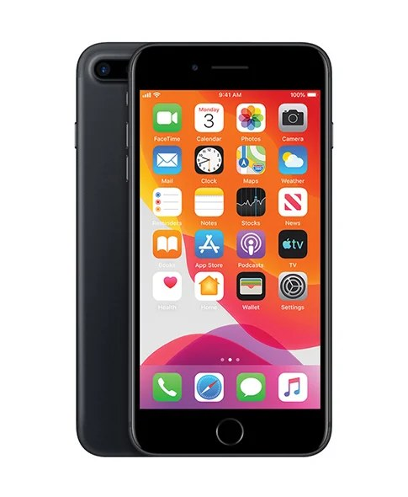  HISTORY  The 7 Plus introduced dual rear cameras and portrait mode — and controversially dropped the headphone jack.  SPECIFICATIONS  CPU: Apple A10 Fusion  RAM: 3 GB  Display: 5.5″ Retina HD · 1920×1080  OS: iOS 10  DID YOU KNOW?  Apple called it 'courage' — removing the 3.5 mm headphone jack pushed users toward wireless audio.  MacDau · No. 049 | MacDau Museum · Vintage Apple Collection  iPad (1st generation)  2010 – 2011  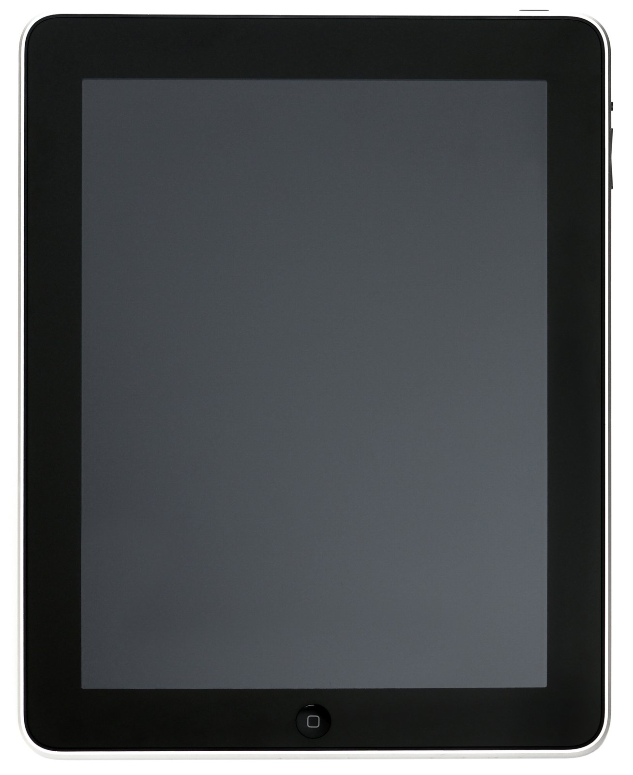  HISTORY  Steve Jobs unveiled the iPad on 27 January 2010 — a third device between laptop and phone, powered by the A4 chip.  SPECIFICATIONS  CPU: Apple A4  RAM: 256 MB  Display: 9.7″ IPS · 1024×768  OS: iPhone OS 3.2  DID YOU KNOW?  Apple sold 15 million iPads in its first nine months — creating the modern tablet market almost overnight.  MacDau · No. 050
MacDau Museum · Vintage Apple Collection  Apple Hi-Fi  2006 – 2007  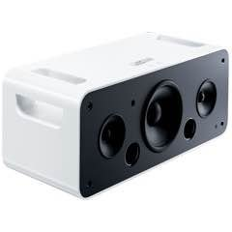  HISTORY  Apple's take on a home stereo — an iPod dock with two tweeters and a subwoofer, announced in February 2006.  SPECIFICATIONS  Connection: iPod 30-pin dock  Speakers: 2 tweeters + subwoofer  Power: AC or 6 × C batteries  Remote: included  DID YOU KNOW?  It flopped — discontinued after about 18 months, and Apple never revisited the home speaker market.  MacDau · No. 051 | MacDau Museum · Vintage Apple Collection  iMac G4 17″  2003 – 2004  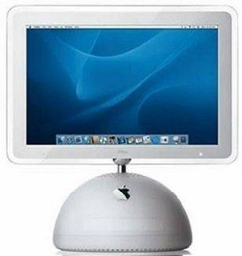  HISTORY  The larger 'sunflower' iMac — the 15″ model grew into this 17″ flat-panel, still floating on its signature chrome arm.  SPECIFICATIONS  CPU: PowerPC G4 · 1.25 GHz  RAM: 256 MB (max 1 GB)  Display: 17″ LCD · 1440×900  OS: Mac OS X 10.3  DID YOU KNOW?  The 17″ panel jumped to 1440×900 — far sharper than most PC LCDs of its day.  MacDau · No. 052

MacDau Museum · Vintage Apple Collection  iMac (2012) 27″  2012 – 2013  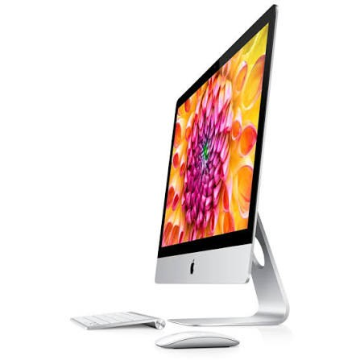  HISTORY  The Late 2012 iMac was dramatically thinner — Apple removed the optical drive and fused the display to the glass.  SPECIFICATIONS  CPU: Intel Core i5 / i7 (Ivy Bridge)  RAM: 8 GB (max 32 GB)  Display: 27″ IPS · 2560×1440  Storage: 1 TB Fusion Drive  DID YOU KNOW?  At just 5 mm at its edge, it was Apple's thinnest desktop ever at the time.  MacDau · No. 053 | MacDau Museum · Vintage Apple Collection  Color OneScanner 600/27  1996 – 1998  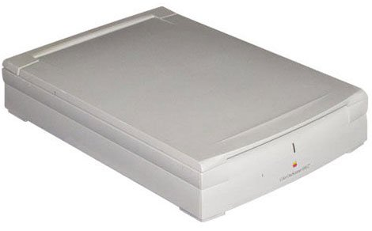  HISTORY  Apple's first colour scanner — 600 dpi optical resolution and 27-bit colour over SCSI, bundled with Ofoto software.  SPECIFICATIONS  Interface: SCSI  Resolution: 600 dpi · 27-bit colour  Scan size: Letter / A4  Software: Ofoto 2.0  DID YOU KNOW?  It plugged straight into any Mac's SCSI port — a rare all-in-one colour scanning solution for its day.  MacDau · No. 054
MacDau Museum · Vintage Apple Collection  ImageWriter II  1985 – 1996  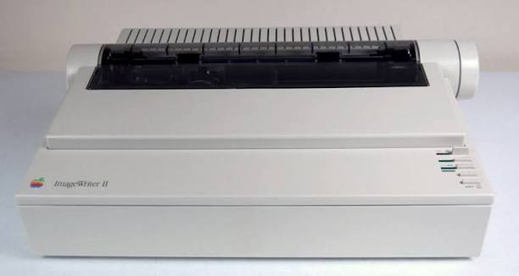  HISTORY  Apple's classic dot-matrix printer — nine pins and the unmistakable sound of a thousand classrooms.  SPECIFICATIONS  Interface: RS-422 serial  Speed: 216 cps (draft)  Resolution: 144 × 144 dpi  Paper: tractor / cut sheet  DID YOU KNOW?  Its 9-pin head used the same technology as the original ImageWriter — but roughly twice as fast.  MacDau · No. 055 | MacDau Museum · Vintage Apple Collection  AppleDesign Powered Speaker  1993 – 1995  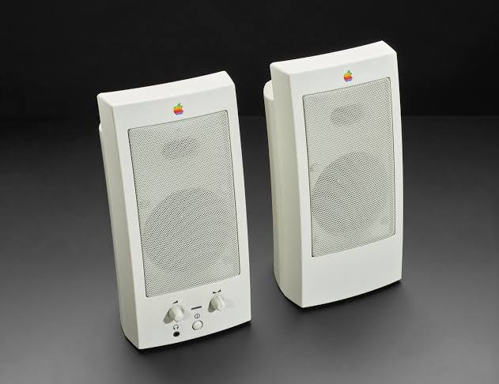  HISTORY  Apple's own powered stereo speakers for the Mac — satellites styled to match the Quadra line.  SPECIFICATIONS  Connection: minijack  Output: stereo · powered  Power: AC adapter  Extras: subwoofer sold separately  DID YOU KNOW?  A matching powered subwoofer was available — Apple's brief foray into desktop audio.  MacDau · No. 056

MacDau Museum · Vintage Apple Collection  Apple Extended Keyboard  1987 – 1990  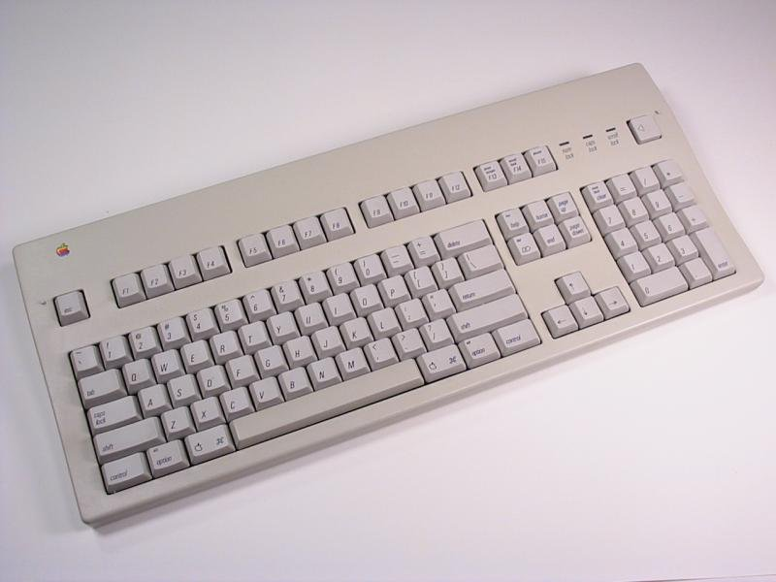  HISTORY  The legendary ADB keyboard — clicky Alps keyswitches and a rock-solid build made it a cult favourite.  SPECIFICATIONS  Interface: ADB  Keys: 105  Switches: Alps clicky  Extras: function keys + numpad  DID YOU KNOW?  Thirty years on, its Alps switches are still prized by mechanical-keyboard enthusiasts.  MacDau · No. 057 | MacDau Museum · Vintage Apple Collection  AppleDesign Keyboard  1994 – 1998  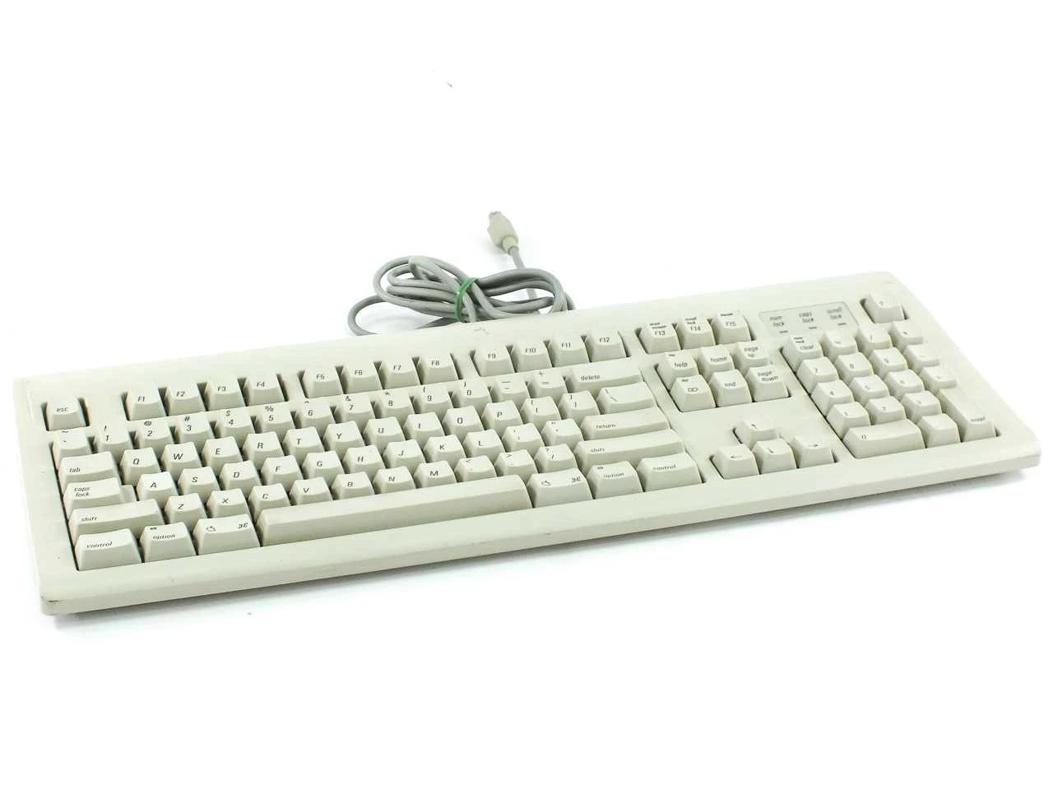  HISTORY  The sleek successor to the Extended Keyboard — quieter and more compact, with the same ADB interface.  SPECIFICATIONS  Interface: ADB  Keys: ~92  Switches: rubber dome  Design: low-profile  DID YOU KNOW?  It dropped the numpad for a space-saver layout — the classic 'pizza-box' Mac companion.  MacDau · No. 058
MacDau Museum · Vintage Apple Collection  Apple Desktop Bus Keyboard  1987 – 1990  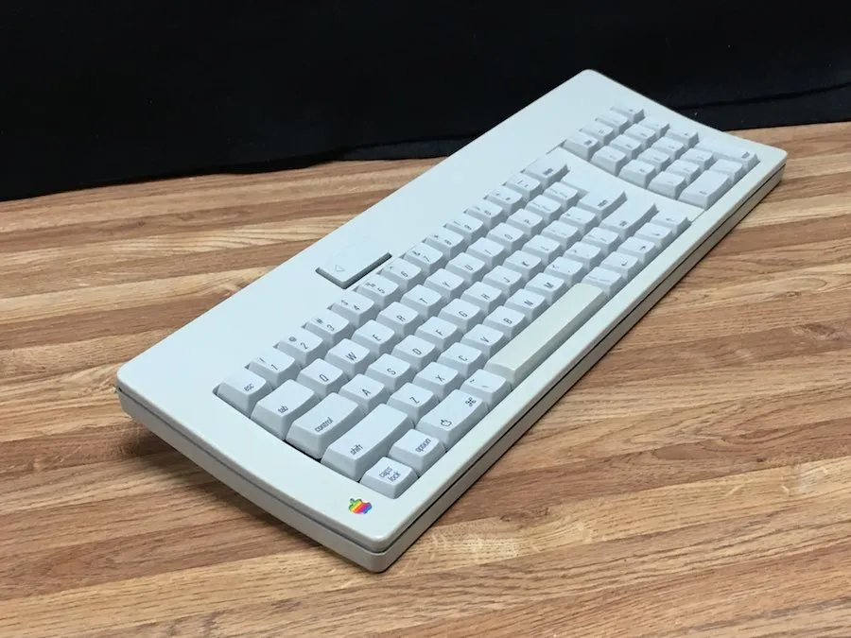  HISTORY  The original ADB keyboard, introduced with the Macintosh SE and II — a wide, low-profile board.  SPECIFICATIONS  Interface: ADB  Keys: 81  Switches: rubber dome  Extras: locking caps lock  DID YOU KNOW?  It introduced the Apple Desktop Bus — the daisy-chain port Apple used until USB arrived.  MacDau · No. 059 | MacDau Museum · Vintage Apple Collection  AppleCD 300  1993 – 1995  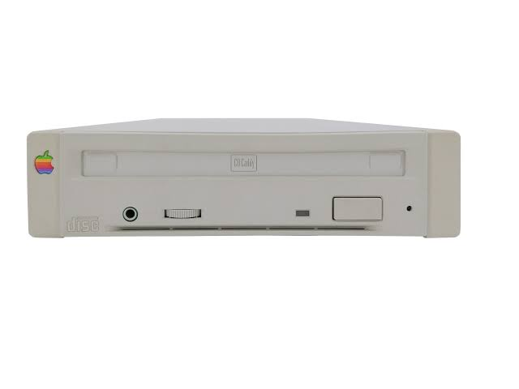  HISTORY  Apple's external SCSI CD-ROM drive — a caddy-based double-speed reader for the Mac.  SPECIFICATIONS  Interface: SCSI  Speed: 2× (300 KB/s)  Tray: caddy  Media: CD-ROM / CD-DA  DID YOU KNOW?  CD-ROM drives were luxury items in 1990 — this one cost around US$599.  MacDau · No. 060

MacDau Museum · Vintage Apple Collection  AppleCD 600e  1995 – 1997  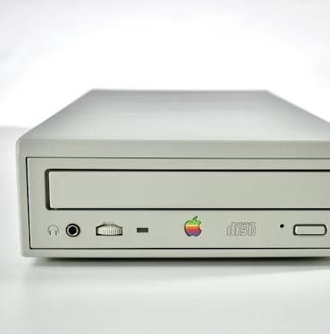  HISTORY  Apple's quad-speed external SCSI CD-ROM drive — four times faster than the 300 series.  SPECIFICATIONS  Interface: SCSI  Speed: 4× (600 KB/s)  Tray: tray  Media: CD-ROM / CD-DA  DID YOU KNOW?  At US$349 it made CD-ROM multimedia affordable — and it read four times faster than the 300 series.  MacDau · No. 061 | MacDau Museum · Vintage Apple Collection  AppleCD SC Plus  1991 – 1992  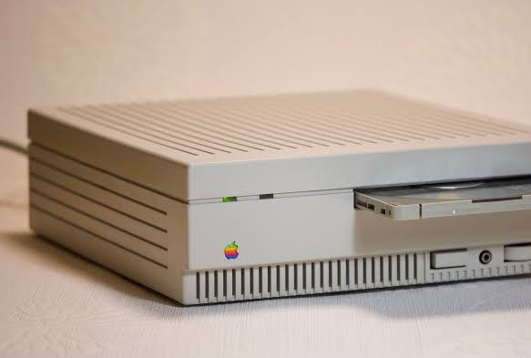  HISTORY  The SC Plus refined Apple's first SCSI CD-ROM drive with better audio support.  SPECIFICATIONS  Interface: SCSI  Speed: 1× (150 KB/s)  Tray: caddy  Media: CD-ROM / CD-DA  DID YOU KNOW?  It was Apple's second CD-ROM drive — the original AppleCD SC had arrived just a year earlier.  MacDau · No. 062
MacDau Museum · Vintage Apple Collection  Apple External Hard Drive  1995 – 1997  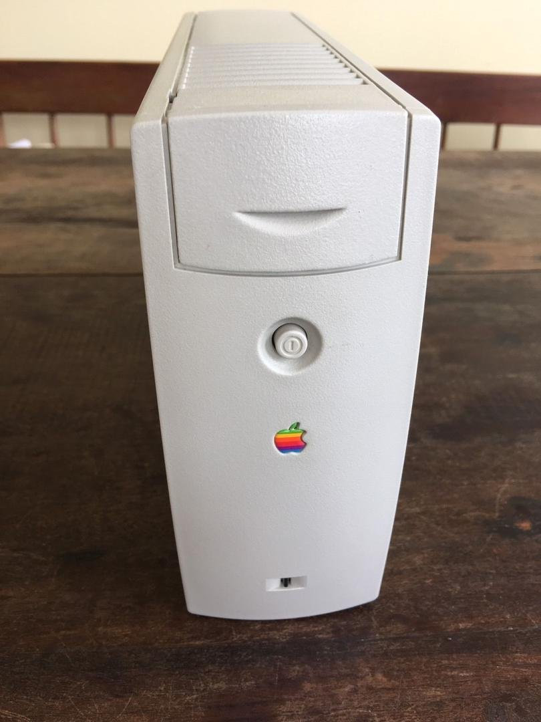  HISTORY  Apple's external SCSI hard drive, model M2115 — built for Apple by LaCie Limited with 2.1 GB on a Quantum drive mechanism.  SPECIFICATIONS  Interface: SCSI  Capacity: 2.1 GB  Model: M2115  Drive: Quantum mechanism  DID YOU KNOW?  It was among the last of Apple's SCSI drives — LaCie assembled it with Quantum mechanisms and Apple ROMs, shipping Silverlining utilities on disk.  MacDau · No. 063 | MacDau Museum · Vintage Apple Collection  Macintosh Quadra 950  1992 – 1995  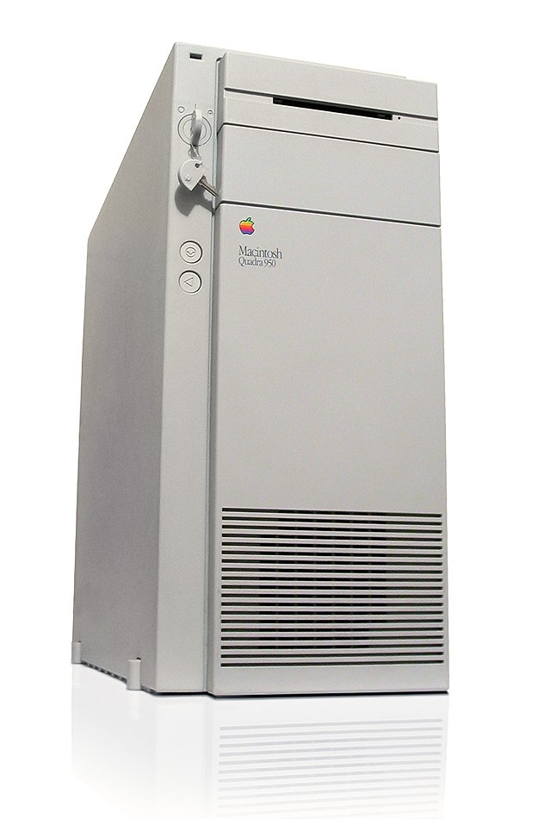  HISTORY  Apple's flagship tower of 1992 — a 33 MHz 68040 with six NuBus slots, built for publishing, servers and power users.  SPECIFICATIONS  CPU: 68040 · 33 MHz  RAM: 8 MB (max 256 MB)  Storage: 400 MB SCSI  OS: System 7.0.1  DID YOU KNOW?  It outlived every other Quadra — kept in production for the server market until 1995, with a key lock on the front.  MacDau · No. 064

MacDau Museum · Vintage Apple Collection  Apple Cinema Display (2000)  2000 – 2003  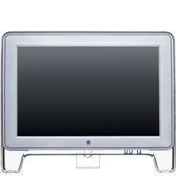  HISTORY  Apple's first professional flat-panel — a 22-inch 'letterbox' LCD. The 2000 revision swapped DVI for the new Display Connector, carrying video, USB and power through one cable, in a shell matched to the G4 Cube.  SPECIFICATIONS  Connection: ADC (video + USB + power)  Display: 22″ LCD · 1600×1024  Brightness: 180 cd/m²  USB: 2-port hub  DID YOU KNOW?  One ADC cable carried video, USB and power — with an ADC Mac there was no external power brick at all.  MacDau · No. 065 | MacDau Museum · Vintage Apple Collection  iPod touch (1st generation)  2007 – 2008  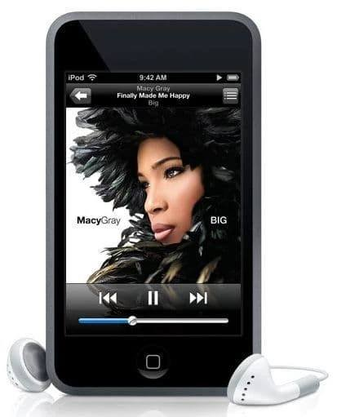  HISTORY  Announced on 5 September 2007, the first iPod touch brought the iPhone's multi-touch interface to the iPod line — Wi-Fi, Safari and YouTube, with no phone inside.  SPECIFICATIONS  CPU: ARM1176 (S5L8900) · 400 MHz  RAM: 128 MB  Display: 3.5″ · 320×480 touch  OS: iPhone OS 1.1  DID YOU KNOW?  It had no speaker at all — every alert and alarm came from a tiny piezoelectric buzzer inside.  MacDau · No. 066
MacDau Museum · Vintage Apple Collection  iPad Air 2  2014 – 2017  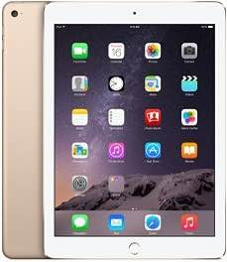  HISTORY  Announced on 16 October 2014, the iPad Air 2 was just 6.1 mm thin — the world's thinnest tablet — with a fully laminated display and Touch ID, both iPad firsts.  SPECIFICATIONS  CPU: Apple A8X · 64-bit tri-core  RAM: 2 GB  Display: 9.7″ Retina · 2048×1536  OS: iOS 8.1  DID YOU KNOW?  It kept getting updates for eight years — from iOS 8.1 to iPadOS 15.  MacDau · No. 067 | MacDau Museum · Vintage Apple Collection  apple ///  1980 – 1984  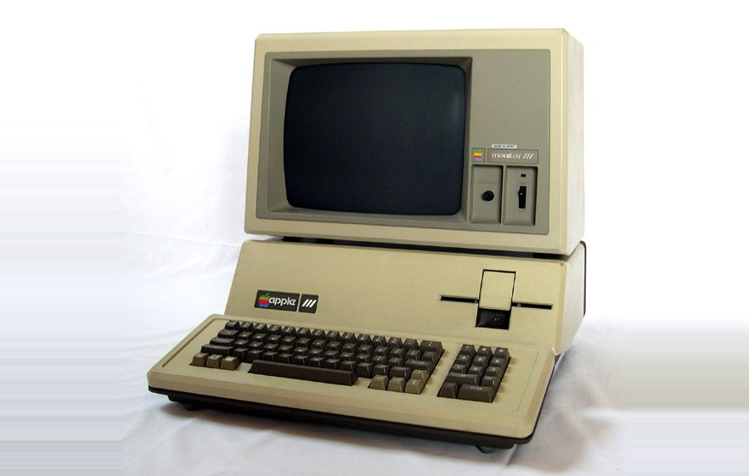  HISTORY  Apple's first business computer, announced on 19 May 1980 as the successor to the Apple II. It paired a 2 MHz 6502A with Apple SOS, but early units ran hot and the first 14,000 were recalled.  SPECIFICATIONS  CPU: Synertek 6502A · 2 MHz  RAM: 128 KB (max 256 KB)  Display: 80×24 text · 560×192  OS: Apple SOS  DID YOU KNOW?  It had no cooling fan — Steve Jobs wanted a silent machine — so heat made chips creep out of their sockets; Apple's official remedy was to lift the computer a few inches and drop it back onto the desk.  MacDau · No. 068

